**UP PoE V2**

**Expansion Board**

Maker Board

UP-POEV2-30W

**User’s Manual 2nd Ed**

##### Copyright Notice

This document is copyrighted, 2025. All rights are reserved. The original manufacturer reserves the right to make improvements to the products described in this manual at any time without notice.

No part of this manual may be reproduced, copied, translated, or transmitted in any form or by any means without the prior written permission of the original manufacturer. Information provided in this manual is intended to be accurate and reliable. However, the original manufacturer assumes no responsibility for its use, or for any infringements upon the rights of third parties that may result from its use.

The material in this document is for product information only and is subject to change without notice. While reasonable efforts have been made in the preparation of this document to assure its accuracy, AAEON assumes no liabilities resulting from errors or omissions in this document, or from the use of the information contained herein.

AAEON reserves the right to make changes in the product design without notice to its users.

##### Acknowledgement

Microsoft®, Windows® are registered trademarks of Microsoft Corp

All other products’ name or trademarks are properties of their respective owners.

##### Packing List

Before setting up your product, please make sure the following items have been shipped:

|  |  |
| --- | --- |
| **Item** | **Quantity** |
| * UP POEV2 Carrier Board | 1 |
| * FPC Cable | 1 |
| * Power Cable  (DC Jack 5.5x2.1mm to 3.96mm 1*2P housing.200mm) | 1 |
| * Screw/Stud Pack | 1 |

If any of these items are missing or damaged, please contact your distributor or sales representative immediately.

##### About this Document

This User’s Manual contains all the essential information, such as detailed descriptions and explanations on the product’s hardware and software features (if any), its specifications, dimensions, jumper/connector settings/definitions, and driver installation instructions (if any), to facilitate users in setting up their product.

Users may refer to the product page at AAEON.com for the latest version of this document.

##### Safety Precautions

Please read the following safety instructions carefully. It is advised that you keep this manual for future references

1. All cautions and warnings on the device should be noted.
2. Make sure the power source matches the power rating of the device.
3. Position the power cord so that people cannot step on it. Do not place anything over the power cord.
4. Always completely disconnect the power before working on the system’s hardware.
5. No connections should be made when the system is powered as a sudden rush of power may damage sensitive electronic components.
6. If the device is not to be used for a long time, disconnect it from the power supply to avoid damage by transient over-voltage.
7. Always disconnect this device from any AC supply before cleaning.
8. While cleaning, use a damp cloth instead of liquid or spray detergents.
9. Make sure the device is installed near a power outlet and is easily accessible.
10. Keep this device away from humidity.
11. Place the device on a solid surface during installation to prevent falls
12. Do not cover the openings on the device to ensure optimal heat dissipation.
13. Watch out for high temperatures when the system is running.
14. Do not touch the heat sink or heat spreader when the system is running
15. Never pour any liquid into the openings. This could cause fire or electric shock.
16. As most electronic components are sensitive to static electrical charge, be sure to ground yourself to prevent static charge when installing the internal components. Use a grounding wrist strap and contain all electronic components in any static-shielded containers.
17. If any of the following situations arises, please the contact our service personnel:
18. Damaged power cord or plug
19. Liquid intrusion to the device
20. Exposure to moisture
21. Device is not working as expected or in a manner as described in this manual
22. The device is dropped or damaged
23. Any obvious signs of damage displayed on the device
24. **DO NOT LEAVE THIS DEVICE IN AN UNCONTROLLED ENVIRONMENT WITH TEMPERATURES BEYOND THE DEVICE’S PERMITTED STORAGE TEMPERATURES (SEE CHAPTER 1) TO PREVENT DAMAGE.**

##### FCC Statement

|  |  |
| --- | --- |
|  | This device complies with Part 15 FCC Rules. Operation is subject to the following two conditions: (1) this device may not cause harmful interference, and (2) this device must accept any interference received including interference that may cause undesired operation. |

***Caution:***

*There is a danger of explosion if the battery is incorrectly replaced. Replace only with the same or equivalent type recommended by the manufacturer. Dispose of used batteries according to the manufacturer’s instructions and your local government’s recycling or disposal directives.*

***Attention:***

*Il y a un risque d’explosion si la batterie est remplacée de façon incorrecte.*

*Ne la remplacer qu’avec le même modèle ou équivalent recommandé par le constructeur. Recycler les batteries usées en accord avec les instructions du fabricant et les directives gouvernementales de recyclage.*

##### China RoHS Requirements (CN)

|  |  |
| --- | --- |
| 产品中有毒有害物质或元素名称及含量 | |
| AAEON 主板/子板/背板 | QO4-381 Rev.A2 |

|  |  |  |  |  |  |  |
| --- | --- | --- | --- | --- | --- | --- |
| 部件名称 | 有毒有害物质或元素 | | | | | |
| 铅  (Pb) | 汞  (Hg) | 镉  (Cd) | 六价铬(Cr(VI)) | 多溴联苯(PBB) | 多溴二苯醚(PBDE) |
| 印刷电路板  及其电子组件 | × | ○ | ○ | ○ | ○ | ○ |
| 外部信号  连接器及线材 | × | ○ | ○ | ○ | ○ | ○ |
| 本表格依据 SJ/T 11364 的规定编制。  ○：表示该有毒有害物质在该部件所有均质材料中的含量均在GB/T 26572标准规定的限量要求以下。  ×：表示该有害物质的某一均质材料超出了GB/T 26572的限量要求，然而该部件仍符合欧盟指令2011/65/EU 的规范。  环保使用期限(EFUP (Environmental Friendly Use Period)) : 10年  备注：此产品所标示之环保使用期限，系指在一般正常使用状况下。 | | | | | | |

##### China RoHS Requirement (EN)

|  |  |
| --- | --- |
| Name and content of hazardous substances in product | |
| AAEON Main Board/Daughter Board/Backplane | QO4-381 Rev.A2 |

|  |  |  |  |  |  |  |
| --- | --- | --- | --- | --- | --- | --- |
| Part Name | Hazardous Substances | | | | | |
| 铅  (Pb) | 汞  (Hg) | 镉  (Cd) | 六价铬(Cr(VI)) | 多溴联苯(PBB) | 多溴二苯醚(PBDE) |
| PCB Assemblies | × | ○ | ○ | ○ | ○ | ○ |
| Connector and Cable | × | ○ | ○ | ○ | ○ | ○ |
| The table is prepared in accordance with the provisions of SJ/T 11364.  ○：Indicates that said hazardous substance contained in all of the homogenous materials for this product is below the limit requirement of GB/T 26572.  ×：Indicates that said hazardous substance contained in at least one of the homogenous materials used for this part is above the limit requirement of GB/T 26572. But this product still be compliance with 2011/65/EU Directive (allowed with 2011/65/EU Annex III of RoHS exemption with number 6(c),7(a),7(c)-1).  EFUP (Environment Friendly Use Period) value: 10 years  Notes: This product defined period of use is under normal condition. | | | | | | |

##### Table of Contents

Chapter 1 - Product Specifications 1

1.1 Specifications 2

Chapter 2 – Hardware Information 3

2.1 Dimensions 4

2.2 Board Layout 5

2.3 List of Jumpers and Connectors 6

2.3.1 FPC/FFC Connector (CN1) 7

2.3.2 USB/UART Wafer (CN3) 8

2.3.3 Power Output (12V) (CN6) 8

2.3.4 PoE LAN Port (CN7) 9

2.3.5 USB 3.2 Gen 1 (5Gbps) (CN8) 10

2.3.6 Fan Connector (Optional) (CN10) 10

Chapter 3 –Carrier Board Installation 11

3.1 Installation Guide 12

Appendix A –Connectors 16

A.1 Connectors 17

**Chapter 1**

# Chapter 1 - Product Specifications

## 1.1 Specifications

| **System** |  |
| --- | --- |
| **I/O** | UP-POEV2-30W-A10-0001:  RJ-45 Input x 1 (10/100/1000M Gigabit Ethernet)  USB 3.2 Gen 1 x 1  41-Pin FPC Connector x 1  UP-POEV2-30W-A10-0002:  RJ-45 Input x 1 (10/100M)  10-Pin Wafer x 1 |
| **Dimension** | 3.37" x 2.22" (85mm x 56mm) |
| **Net Weight** | 0.1 lb. (0.04Kg) |
| **Gross Weight** | 0.13 lb. (0.06Kg) |
| **Operating Temperature** | 32°F ~ 140°F (0°C ~ 60°C), 0.5m/s airflow |
| **Operation Humidity** | 10% ~ 80% relative humidity, non-condensing |
| **Certification** | CE/FCC Class A, RoHS Compliant, REACH |

**Chapter 2**

# Chapter 2 – Hardware Information

## 2.1 Dimensions

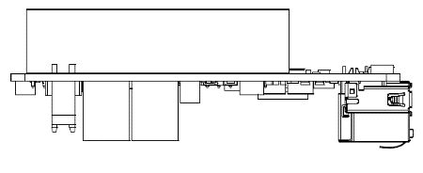

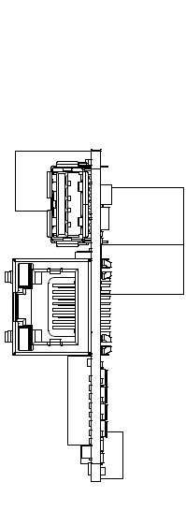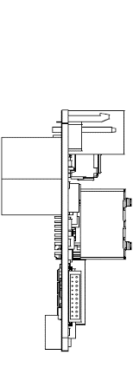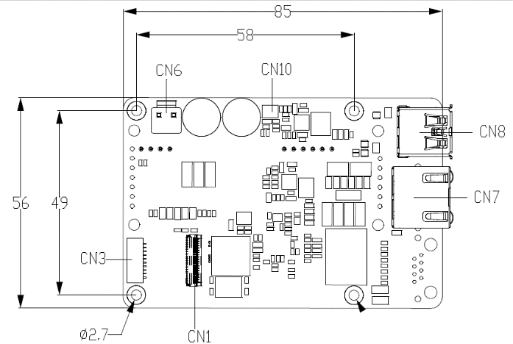

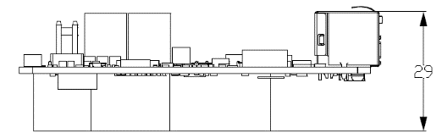

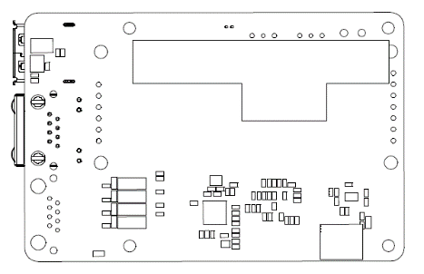

## 2.2 Board Layout

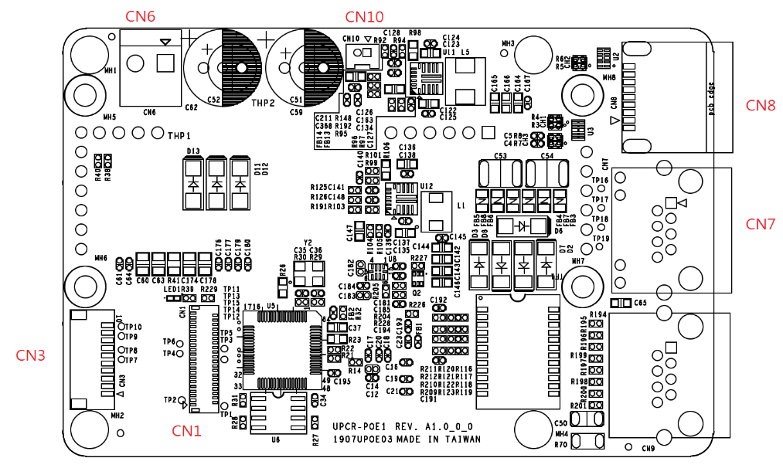

## 2.3 List of Jumpers and Connectors

|  |  |
| --- | --- |
| Label | Functional Description |
| CN1 | FPC/FFC Connector |
| CN3 | USB/UART Wafer |
| CN6 | Power Output (12V) |
| CN7 | PoE LAN Port |
| CN8 | USB 3.2 Gen 1 Port |
| CN10 | Fan Connector (Optional) |

### 2.3.1 FPC/FFC Connector (CN1)

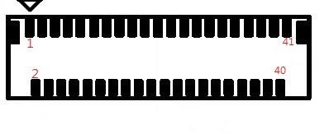

| Pin | Signal Description | Pin | Signal Description |
| --- | --- | --- | --- |
| 1 | GND | **2** | NC |
| 3 | NC | **4** | GND |
| 5 | USB3 RX_N | **6** | USB3 RX_P |
| 7 | GND | **8** | USB3 TX_N |
| 9 | USB3 TX_P | **10** | GND |
| 11 | NC | **12** | USB2 DN |
| 13 | USB2 DP | **14** | PCIE Clock_N |
| 15 | PCIE Clock_P | **16** | GND |
| 17 | PCIE_RXP | **18** | PCIE_RXN |
| 19 | GND | **20** | PCIE_TXN |
| 21 | PCIE_TXP | **22** | GND |
| 23 | PCIe Wake(1.8V) | **24** | Suspend clock |
| 25 | NC | **26** | NC |
| 27 | NC | **28** | Platform reset |
| 29 | Sleep S3(3.3V) | **30** | Sleep S0(3.3V) |
| 31 | GND | **32** | +1.8V |
| 33 | +1.8V | **34** | NC |
| 35 | NC | **36** | NC |
| 37 | NC | **38** | NC |
| 39 | NC | **40** | NC |
| 41 | GND | **H1** | GND |
| H2 | GND | **-** | - |

### 2.3.2 USB/UART Wafer (CN3)

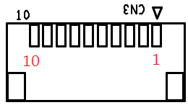

| Pin | Signal Description | Pin | Signal Description |
| --- | --- | --- | --- |
| 1 | +5V | **2** | USB2_DN |
| 3 | USB2_DP | **4** | GND |
| 5 | +5V | **6** | NC |
| 7 | NC | **8** | GND |
| 9 | NC | **10** | NC |
| H1 | GND | **H2** | GND |

### 2.3.3 Power Output (12V) (CN6)

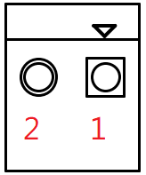

| Pin | Signal Description | Pin | Signal Description |
| --- | --- | --- | --- |
| 1 | +12V(Output) | **2** | GND |

### 2.3.4 PoE LAN Port (CN7)

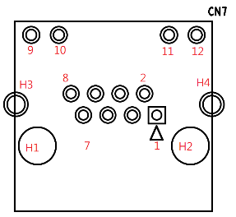

| Pin | Signal Description | Pin | Signal Description |
| --- | --- | --- | --- |
| 1 | LAN_TMDI0+ | **2** | LAN_TMDI0- |
| 3 | LAN_TMDI1+ | **4** | LAN_TMDI2+ |
| 5 | LAN_TMDI2- | **6** | LAN_TMDI1- |
| 7 | LAN_TMDI3+ | **8** | LAN_TMDI3- |
| 9 | LAN LED Active+ | **10** | LAN LED Active- |
| 11 | LAN Link 1000# | **12** | LAN Link 100# |
| H1 | NC | **H2** | NC |
| H3 | Chassis GND | **H4** | Chassis GND |

### 2.3.5 USB 3.2 Gen 1 (5Gbps) (CN8)

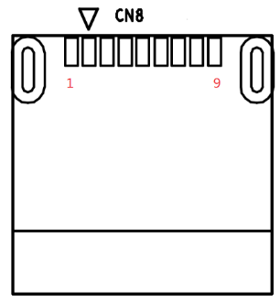

| Pin | Signal Description | Pin | Signal Description |
| --- | --- | --- | --- |
| 1 | +5V | **2** | USB2_DN |
| 3 | USB2_DP | **4** | GND |
| 5 | USB3_RXN | **6** | USB3_RXP |
| 7 | GND | **8** | USB3_TXN |
| 9 | USB3_TXP | **-** | - |
| H1 | GND | **H2** | GND |

### 2.3.6 Fan Connector (Optional) (CN10)

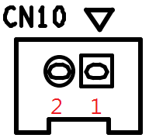

| Pin | Signal Description | Pin | Signal Description |
| --- | --- | --- | --- |
| 1 | +12V | **2** | GND |

**Chapter 3**

# Chapter 3 –Carrier Board Installation

## 3.1 Installation Guide

For this process you will need a Phillips head screwdriver.

**Step 1**: Remove the four (4) screws on the board.

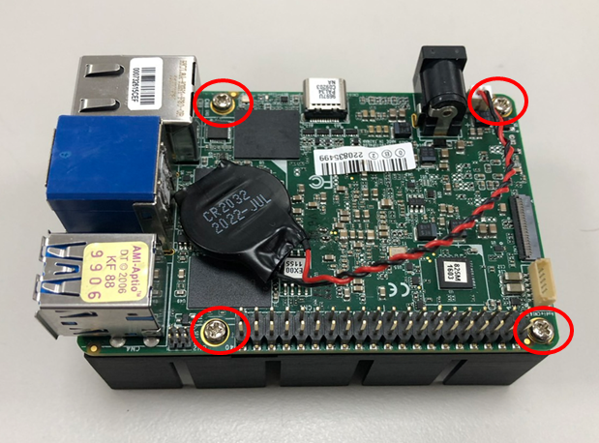

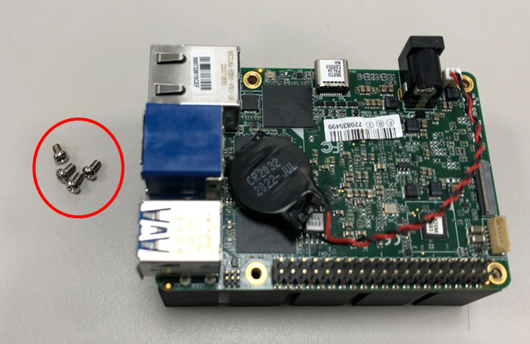

**Step 2**: Lock the four pillars and make sure to unlock the UP 4000’s FPC connector.

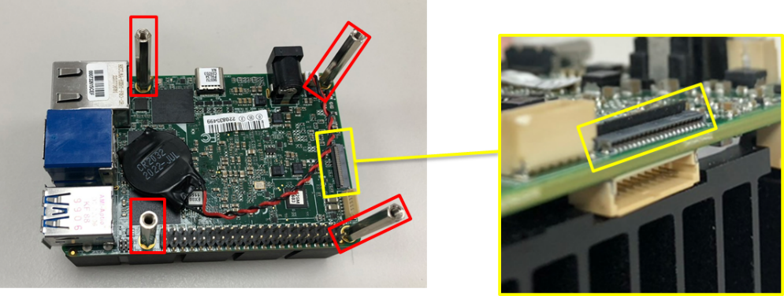

**Step 3**: Plug the FPC cable into the FPC connector, noting the direction of the FPC cable via the printing on its top side, as shown.

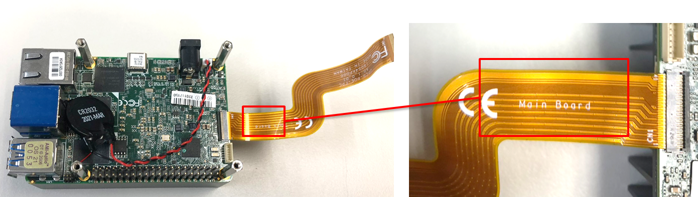

**Step 4**: Align the PoE 30W module with the stud hole, and lock it with the four (4) screws that were removed in step 1. Then, wrap the FPC cable up and insert it into the unlocked FPC connector on the POE module.

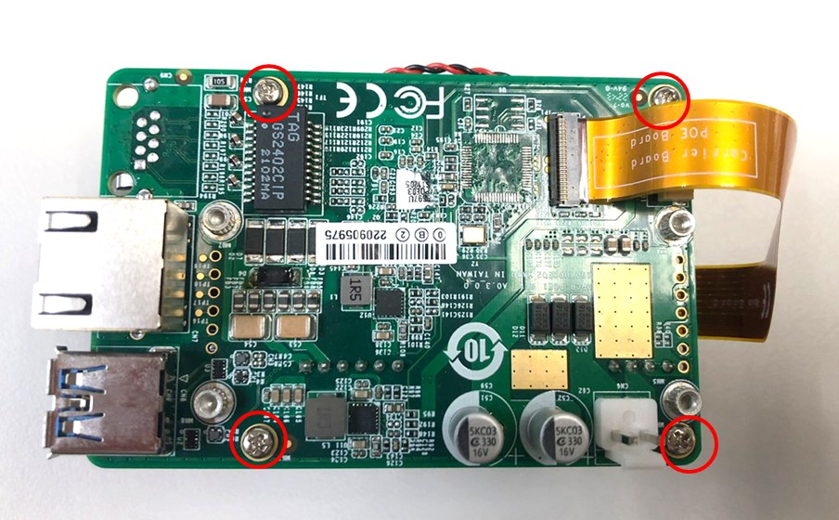

**Step 5**: Plug the power cable into the power jack and plug the other side into the PoE module’s wafer.

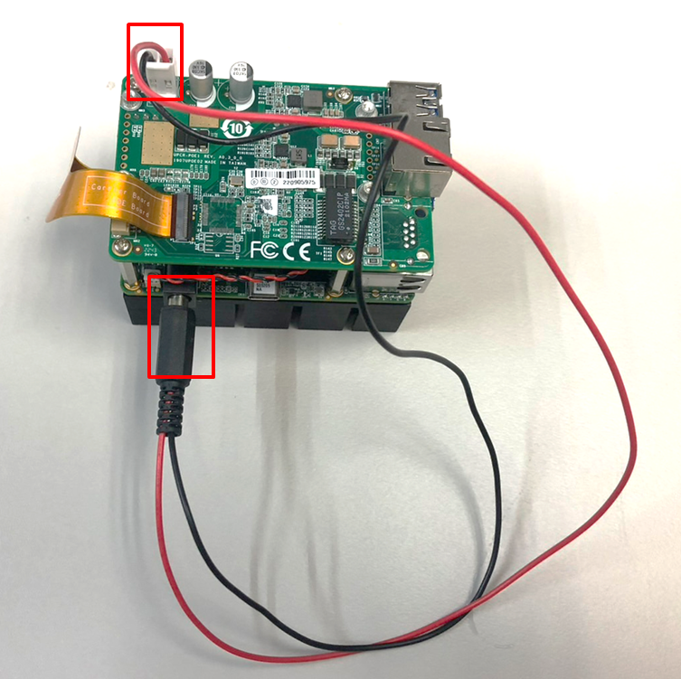

**Appendix A**

# Appendix A –Connectors

## A.1 Connectors

This table provides detailed information about the cables and connectors used by the UP POE V2 Expansion Board (UP-POEV2-30W-A10-0001). If you have any questions about the configuration of your board, please contact your AAEON sales representative.

| **Label** | **Description** | **Connector Type** |
| --- | --- | --- |
| **CN1** | FPC/FFC | (TF)FPC/FFC Conn.41P.90D(F).SMD.0.6mm.Hirose.  FH35C-41S-0.3SHW(50) |
| **CN3** | USB/UART Wafer | (TF)Wafer.SMD.Pitch=1.0mm.10P.90D.MALE.BOX  NON LOCK.PINREX.710-74-10TWRG.NY9T |
| **CN6** | Power Output (12V) | (TF)WAFER.2P.180D(M).3.96mm.W/LOCK.HO-  BASE.3962-WS-2 |
| **CN7** | POE LAN | (TF)RJ45.12P.90D(F).W/LED(L-Y,R-G/O).W/O Transformer.W/ Spring (TOP).DIP.LZ.R31-C118420-3151 |
| **CN8** | USB 3.2 Gen 1 | (TF)USB3.0 Connector.Single Port.Type A.  9P.90D(F).SMD.Trontek.930-00406-A91-22 |
| **CN10** | FAN Conn  (Optional) | (TF)Wafer.SMD.Pitch=1.25mm.2P.180D.MALE  .BOXNON LOCK.PINREX.712-P91-025WEH.(PIP) |