AAEON Technology INC.

ISO-9001/ISO-14001 Certified

Industrial Automation PCs

MB-668
Thermal Image Analysis Report

Release Date: JUNE.30, 2000

__________ __________ __________ __________

Issue Stamp QA Manager QE Manager Test Engineer

Thermal Image Analysis
Ⅰ. Model Name: PCM-668
Ⅱ. Description: Socket 370 LPX Board with LD, LAN, Audio, & 4 COMs
Ⅲ. Date: JUNE. 30, 2000
Ⅳ. Measure Site: AAEON QE Dept.
Ⅴ. Issued by : Fenglin Dong
Ⅵ.Equipment: TVS-100 series by NIPPON AVIONICS CO., LTD.
Ⅶ. Simulation Environment:
•Temperature: 25.2 degrees C
•CPU: Celeron
•RAM: 128 MB
•Hardware: DiskOnChip
•Application Software: QAPLUS/FE V5.2
•Take Picture Time: Power on 30 minutes after
Ⅷ. Prediction Result:
- Component Side: 1/4
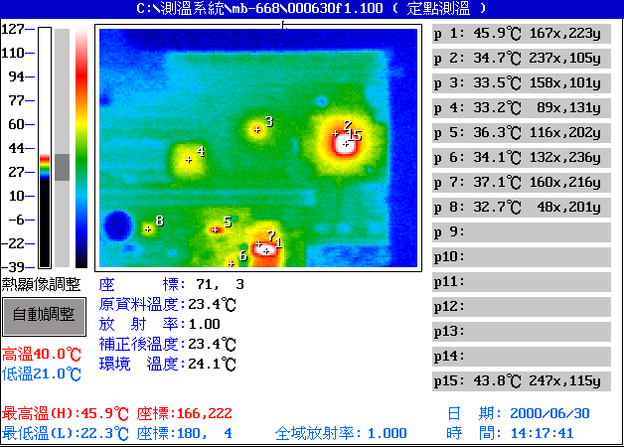

Point | Position | Describe | Ts | Tm | Note
1 | U25 | ICS, 9248-39 | 70 | 45.9 | ※ = -10.9
2 | U10 | INTEL,FW82443BX SL2VH | 75 | 34.7
3 | U1 |  |  | 33.5
4 | U14 |  |  | 33.2
5 | U3 | TI, 7407 | 75 | 36.3
6 | U36 | ICS, ICS9112-16 | 70 | 34.1
7 | U25 | ICS, 9248-39 | 70 | 37.1 | ※ = -2.1
8 | U23 |  |  | 32.7
9 | ---
10 | ---
11 | ---
12 | ---
13 | ---
14 | ---
15 | U10 |  |  | 43.8
1. Operation Temperature (℃):
Ts = Defined by component specification ; Tm = Measured by QE
2. ※ = Ts - (Tm + 60 - 25 )

Component Side: 2/4
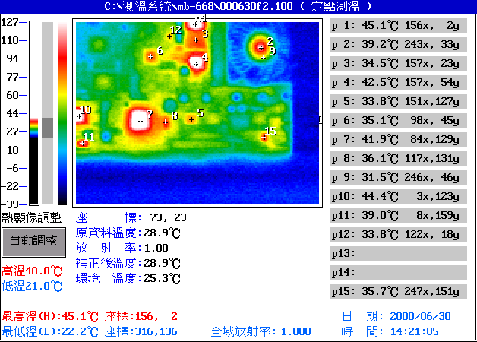

Point | Position | Describe | Ts | Tm | Note
1 | U25 | ICS, 9248-39 | 70 | 45.1 | ※ = -10.1
2 | CPU1 | CPU |  | 39.2
3 | ---
4 | ---
5 | ---
6 | U37 |  |  | 35.1
7 | U12 | CHIPS, B69000 | 70 | 41.9 | ※ = -6.9
8 | U9 |  |  | 36.1
9 | CPU1 |  |  | 31.5
10 | U26 | REALTEK, RTL8139B | 70 | 44.4 | ※ = -9.4
11 | Y5 | EPSON, SG-8002JC50 | 70 | 39.0 | ※ = -4
12 | U36 |  |  | 33.8
13 | ---
14 | ---
15 | U15 |  |  | 35.7
1. Operation Temperature (℃):
Ts = Defined by component specification ; Tm = Measured by QE
2. ※ = Ts - (Tm + 60 - 25 )

Component Side: 3/4
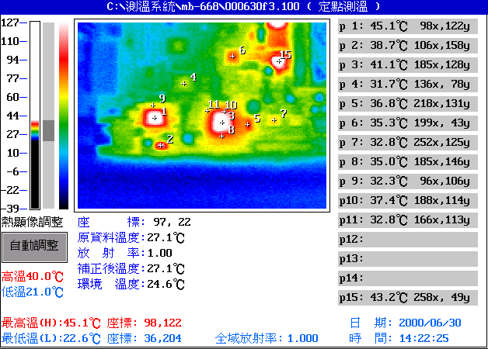

Point | Position | Describe | Ts | Tm | Note
1 | U26 | REALTEK, RTL8139B | 70 | 45.1 | ※ = -10.1
2 | Y5 | EPSON, SG-8002JC50 | 70 | 38.7
3 | U12 | CHIPS, B69000 | 70 | 41.1 | ※ = -6.1
4 | U19 |  |  | 31.7
5 | U9 |  |  | 32.3
6 | U37 | Aureal, AU8810-A2ACAA | 70 | 35.3
7 | ---
8 | U12 |  |  | 35.0
9 | U26 |  |  | 32.3
10 | U12 | CHIPS, B69000 | 70 | 37.4
11 | U12 | CHIPS, B69000 | 70 | 32.8
12 | ---
13 | ---
14 | ---
15 | ---
1. Operation Temperature (℃):
Ts = Defined by component specification ; Tm = Measured by QE
2. ※ = Ts - (Tm + 60 - 25 )

Component Side: 4/4
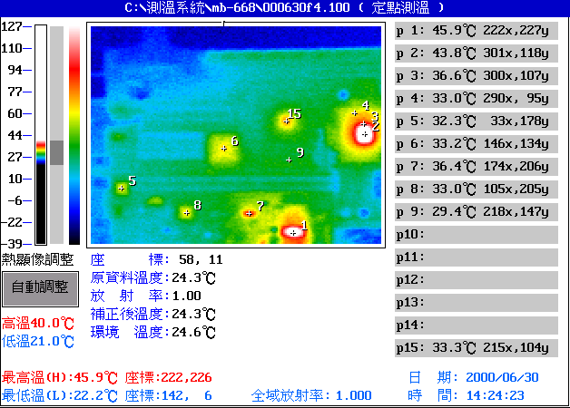

Point | Position | Describe | Ts | Tm | Note
1 | U25 | ICS, 9248-39 | 70 | 45.9 | ※ = -10.9
2 | U10 | INTEL, FW82443BX SL2VH | 70 | 43.8 | ※ = -8.8
3 | U10 |  |  | 36.6
4 | U10 |  |  | 33.0
5 | U38 |  |  | 32.3
6 | U14 | TENYUN, 540-99-044-17-400 | 70 | 33.2
7 | U3 | TI, 7407 | 75 | 36.4
8 | U23 |  |  | 33.0
9 | --- |  |  | 29.4
10 | ---
11 | ---
12 | ---
13 | ---
14 | ---
15 | U1 | INTEL, FW82371EB SL37M | 70 | 33.3
1. Operation Temperature (℃):
Ts = Defined by component specification ; Tm = Measured by QE
2. ※ = Ts - (Tm + 60 - 25 )

- Solder Side: 1/4
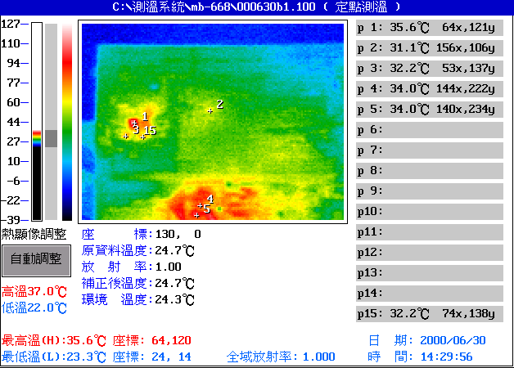

Point | Position | Describe | Ts | Tm | Note
1 | ---
2 | ---
3 | ---
4 | ---
5 | ---
6 | ---
7 | ---
8 | ---
9 | ---
10 | ---
11 | ---
12 | ---
13 | ---
14 | ---
15 | ---
1. Operation Temperature (℃):
Ts = Defined by component specification ; Tm = Measured by QE
2. ※ = Ts - (Tm + 60 - 25 )

Solder Side: 2/4
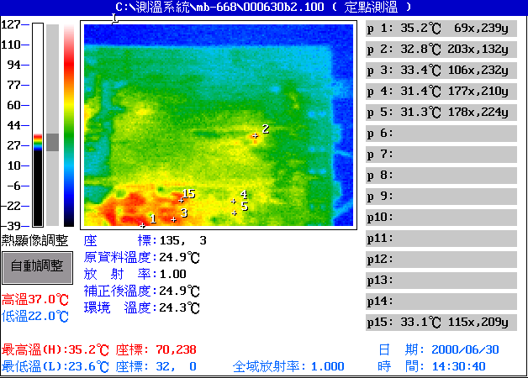

Point | Position | Describe | Ts | Tm | Note
1 | ---
2 | ---
3 | ---
4 | ---
5 | U16 | TI, NE555 |  | 31.3
6 | ---
7 | ---
8 | ---
9 | ---
10 | ---
11 | ---
12 | ---
13 | ---
14 | ---
15 | ---
1. Operation Temperature (℃):
Ts = Defined by component specification ; Tm = Measured by QE
2. ※ = Ts - (Tm + 60 - 25 )

Solder Side: 3/4
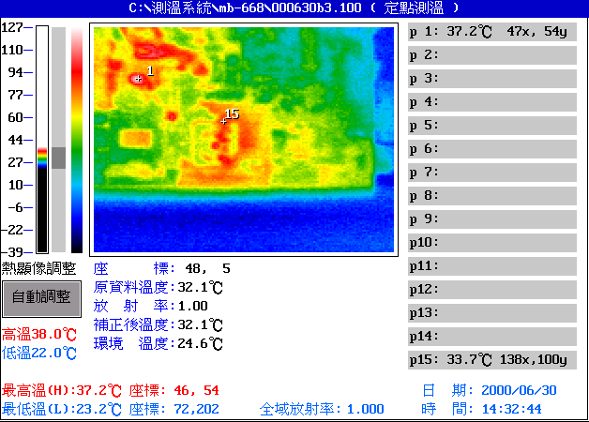

Point | Position | Describe | Ts | Tm | Note
1 | ---
2 | ---
3 | ---
4 | ---
5 | ---
6 | ---
7 | ---
8 | ---
9 | ---
10 | ---
11 | ---
12 | ---
13 | ---
14 | ---
15 | ---
1. Operation Temperature (℃):
Ts = Defined by component specification ; Tm = Measured by QE
2. ※ = Ts - (Tm + 60 - 25 )

Solder Side: 4/4
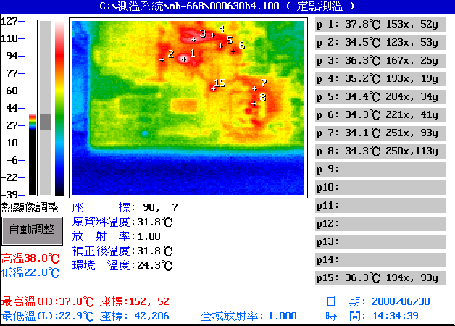

Point | Position | Describe | Ts | Tm | Note
1 | ---
2 | ---
3 | ---
4 | ---
5 | ---
6 | ---
7 | ---
8 | ---
9 | ---
10 | ---
11 | ---
12 | ---
13 | ---
14 | ---
15 | ---
1. Operation Temperature (℃):
Ts = Defined by component specification ; Tm = Measured by QE
2. ※ = Ts - (Tm + 60 - 25 )

