AAEON Technology INC.

ISO-9001/ISO-14001 Certified

Industrial Automation PCs

SBC-658
Thermal Image Analysis Report

Release Date: JUNE.29, 2000

__________ __________ __________ __________

Issue Stamp QA Manager QE Manager Test Engineer

Thermal Image Analysis
Ⅰ. Model Name: SBC-658
Ⅱ. Description: FC/Socket 370 Half-size CPU Card with LCD, Ethernet, & SSD
Ⅲ. Date: JUNE. 29, 2000
Ⅳ. Measure Site: AAEON QE Dept.
Ⅴ. Issued by : Fenglin Dong
Ⅵ.Equipment: TVS-100 series by NIPPON AVIONICS CO., LTD.
Ⅶ. Simulation Environment:
•Temperature: 25.5 degrees C
•CPU: PIII 700
•RAM: 128 MB (NEC D4564841G5-A80-9JF)
•Hardware: DiskOnChip
•Application Software: QAplusfe V5.2
•Take Picture Time: Power on 30 minutes after
Ⅷ. Prediction Result:
- Component Side:
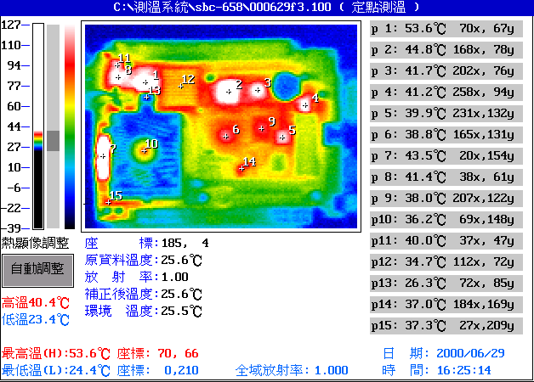

Point | Position | Describe | Ts | Tm | Note
1 | U2 | ICS, 9248-39 | 70 | 53.6 | ※
2 | U4 | INTEL, C&TM6900 | 75 | 44.8 | ※
3 | U5 | INTEL, 82559ER | 75 | 41.7 | ※
4 | U7 | LINEAR, LTC485CS8 | 70 | 41.2 | ※
5 | U14 |  |  | 39.9
6 | U13 |  |  | 38.8
7 | U1 | HARRIS, HIN213CA | 75 | 43.5 | ※
8 | CN6 | 鴻呈, AT-PH13-SMT-14-2-G | 70 | 41.4 | ※
9 | U11 |  |  | 38.0
10 | CPU1 |  |  | 36.2
11 | CN6 |  |  | 40.0
12 | U3 |  |  | 34.7
13 | --- |  |  | ---
14 | U21 |  |  | 37.0
15 | --- |  |  | ---
1. Operation Temperature (℃):
Ts = Defined by component specification ; Tm = Measured by QE
2. ※ = Ts - (Tm + 60 - 25 )

- Solder Side:
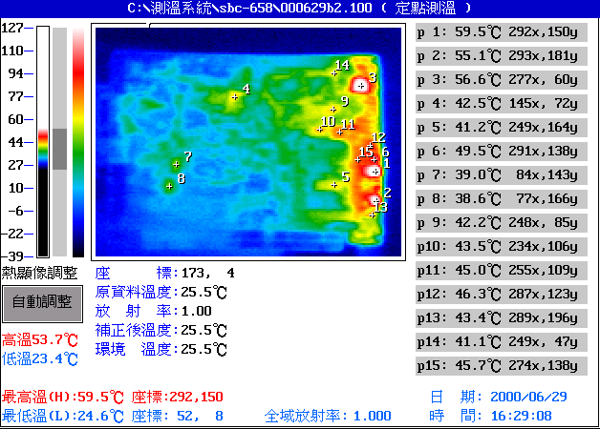

Point | Position | Describe | Ts | Tm | Note
1 | Q6 | PHILIPS, PHD50N03LT | 75 | 59.5 | ※ = -19.5
2 | Q5 | PHILIPS, PHD50N03LT | 75 | 55.1 | ※ = -15.1
3 | Q2 | AMS, AMS1083CM | 75 | 56.6 | ※ = -16.6
4 | --- |  |  | ---
5 | C115 |  |  | 41.2
6 | --- |  |  | ---
7 | --- |  |  | ---
8 | --- |  |  | ---
9 | --- |  |  | ---
10 | U27 | 74F070 | 70 | 43.5 | ※ = -8.5
11 | Q3 | AMS, AMS1084CM-1.5 | 70 | 45.0 | ※ = -10
12 | C108 | MCC, 1μF,10V,+80/-20%, 0603SMD | 75 | 46.3 | ※ = -6.3
13 | --- |  |  | ---
14 | --- |  |  | ---
15 | --- |  |  | ---
1. Operation Temperature (℃):
Ts = Defined by component specification ; Tm = Measured by QE
2. ※ = Ts - (Tm + 60 - 25 )

