AAEON

AAEON Technology INC.

ISO-9001/ISO-14001 Certified

Industrial Automation PCs

SBC-776
Temperature Test Report

Release Date : May/16/2001

__________ __________ __________ __________

Issue Stamp QA Manager QE Manager Test Engineer

Environment
Model Name : SBC-776
Test Date : 01-05-16
Test Site : AAEON QE Dept.
Performed by : Rex Chang
Test Standard :
Select | NO. |  | Description
√ | IEC 68-2-30 |  | Test DB : Damp Heat Test
√ | IEC 68-2-61 |  | Test Z/ABD : Climatic Sequence Test
Testing Item :
Temperature & Humidity Cycle
Test Temperature & Humidity Power On/Off Test
Additional Test Peripheral :
Configuration |  | Model
Test Software |  | QAPlus 5.5
Test Fixture |  | Power on/off(110V) Fixture
Testing Equipment :
Programmable Temperature & Humidity Chamber
Model : Ths-D4L+-100
S/N : 1241
Date of Calibration : 07-10-2000
Sample Configuration & Quantity Under Test :
The PCM-6896 is a FC/Socket 370 media single board computer.
1.CPU : Intel 1GHz
2.DRAM : PC-133 SD 256MB (NEC D45128841G5-A75-9JF)
3.Chipset : Intel 815E
4.VGA Chipset : Intel 815E Share system memory up to 4MB(MAX)
5.I/O Chipset : Winbond 83627HF. Fully 16 bit I/O decoded.
6.SCSI Chipset : AdvanSys 38C0800.
Test Result :
Standard | Description |  |  | Result
IEC 68-2-30 | Temperature & Humidity Power On/Off Test |  |  | Pass
IEC 68-2-61 | Temperature & Humidity Cycle Test(Run QAPlus 5.5) |  |  | Pass

Environment
Temperature & Humidity Power On/Off Test

Environment
Temperature & Humidity Power On/Off Test
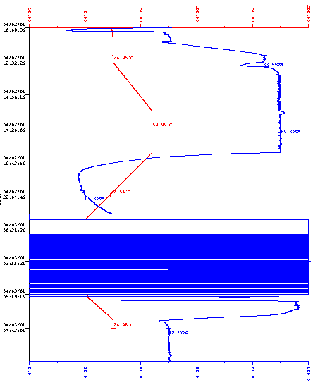

Environment
Temperature & Humidity Cycle Test(Run QAPlus 5.5)

Environment
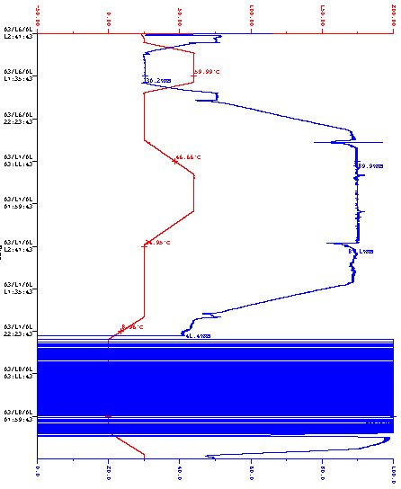Temperature & Humidity Cycle Test(Run QAPlus 5.5)

