SBC-656
Environment Test Report

Release Date : Oct. 19, 1999

__________ __________ __________ __________

Issue Stamp QA Manager QE Manager Test Engineer

Environment
Model Name : SBC-656
Test Date : 99-10-15
Test Site : AAEON QE Dept.
Performed by : George Hsin
Test Standard :
Select | NO. |  | Description
√ | IEC 68-2-30 |  | Test DB : Damp Heat Test
√ | IEC 68-2-61 |  | Test Z/ABD : Climatic Sequence Test
Testing Item :
Temperature & Humidity Cycle
Test Temperature & Humidity Power On/Off Test
Additional Test Peripheral :
Configuration |  | Model
Test Software |  | QAPluse/FE V5.29
Test Fixture |  | Power on/off(110V) Fixture
Testing Equipment :
Programmable Temperature & Humidity Chamber
Model : Ths-D4L+-100
S/N : 1241
Date of Calibration : 07-10-1998
Sample Configuration & Quantity Under Test :
Use PCM-656 All-in-One Socket 370 Single Board with the following options installed .
1.CPU : Celeron 400MHz
2.DRAM : 32MB(D4516821AG5-A10-9NF PC-100)
3.Chipset : Intel 440BX
4.VGA Chipset : C&T B69000
5.I/O Chipset : Winbond W83977TF
Test Result :
Standard | Description |  |  | Result
IEC 68-2-30 | Temperature & Humidity Power On/Off Test |  |  | Pass
IEC 68-2-61 | Temperature&HumidityCycle Test(Run QAPluse/FE V5.29) |  |  | Pass

Environment
Temperature & Humidity Power On/Off Test

Environment

Temperature & Humidity Power On/Off Test

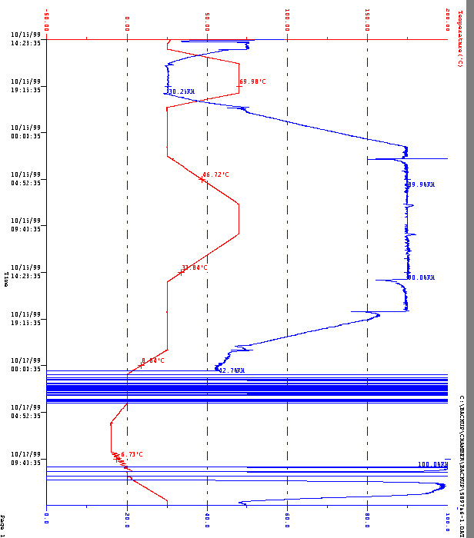

Environment
Temperature & Humidity Cycle Test(Run AMIDIAG 5.11)

Environment
Temperature & Humidity Cycle Test(Run AMIDIAG 5.11)
