AAEON

AAEON Technology INC.

ISO-9001/ISO-14001 Certified

Industrial Automation PCs

PCM-7890
Environment Test Report

Release Date : Apr./09/1999

__________ __________ __________ __________

Issue Stamp QA Manager QE Manager Test Engineer

Environment
Model Name : PCM-7890
Test Date : 99-04-09
Test Site : AAEON QE Dept.
Performed by : Wenyuan Yang
Test Standard :
Select | NO. |  | Description
√ | IEC 68-2-30 |  | Test DB : Damp Heat Test
√ | IEC 68-2-61 |  | Test Z/ABD : Climatic Sequence Test
Testing Item :
Temperature & Humidity Cycle
Test Temperature & Humidity Power On/Off Test
Additional Test Peripheral :
Configuration |  | Model
Test Software |  | AMIDIAG 5.11
Test Fixture |  | Power on/off(110V) Fixture
Testing Equipment :
Programmable Temperature & Humidity Chamber
Model : Ths-D4L+-100
S/N : 1241
Date of Calibration : 07-10-1998
Sample Configuration & Quantity Under Test :
Use PCM-7890 Little Board with the following options installed .
1.CPU : Intel Pentium II 400MHZ
2.SDRAM : 32MB(NEC D4516821AG5)
3.Chipset : Intel 440BX
4.VGA Chipset : C&T 69000
5.I/O Chipset : ITE IT8661F/Winbond W83977TF
Test Result :
Standard | Description |  |  | Result
IEC 68-2-30 | Temperature & Humidity Power On/Off Test |  |  | Pass
IEC 68-2-61 | Temperature & Humidity Cycle Test(Run AMIDIAG 5.11) |  |  | Pass

Environment
Temperature & Humidity Power On/Off Test

Environment
Temperature & Humidity Power On/Off Test
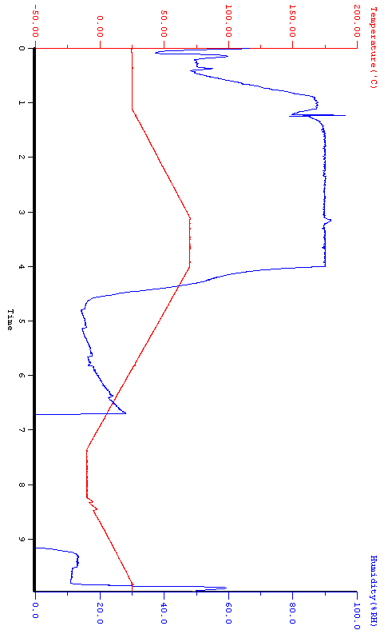

Environment
Temperature & Humidity Cycle Test(Run AMIDIAG 5.11)

Environment
Temperature & Humidity Cycle Test(Run AMIDIAG 5.11)
