PCM-6890
Environment Test Report

Release Date : Nov. 29, 1999

__________ __________ __________ __________

Issue Stamp QA Manager QE Manager Test Engineer

Environment
Model Name : PCM-6890
Test Date : 1999-11-29
Test Site : AAEON QE Dept.
Performed by : George Hsin
Test Standard :
Select | NO. |  | Description
√ | IEC 68-2-30 |  | Test DB : Damp Heat Test
√ | IEC 68-2-61 |  | Test Z/ABD : Climatic Sequence Test
Testing Item :
Temperature & Humidity Cycle
Test Temperature & Humidity Power On/Off Test
Additional Test Peripheral :
Configuration |  | Model
Test Software |  | QAPluse/FE V5.4
Test Fixture |  | Power on/off(110V) Fixture
Testing Equipment :
Programmable Temperature & Humidity Chamber
Model : Ths-D4L+-100
S/N : 1241
Date of Calibration : 07-10-1998
Sample Configuration & Quantity Under Test :
Use PCM-6890B uses the latest Intel FC-371 Pentium III, Celeron, and compatible CPUs Compact Board with the following options installed .
1.CPU : Celeron 300MHz
2.DRAM : 32MB(D4516821AG5-A10-9NF PC-100)
3.Chipset : Intel 440BX
4.VGA Chipset : C&T 69000
5.I/O Chipset : ITE IT8661F/Winbond W83977EF
Test Result :
Standard | Description |  |  | Result
IEC 68-2-30 | Temperature & Humidity Power On/Off Test |  |  | Pass
IEC 68-2-61 | Temperature&HumidityCycle Test(Run QAPluse/FE V5.4) |  |  | Pass

Environment
Temperature & Humidity Power On/Off Test

Environment
Temperature & Humidity Power On/Off Test
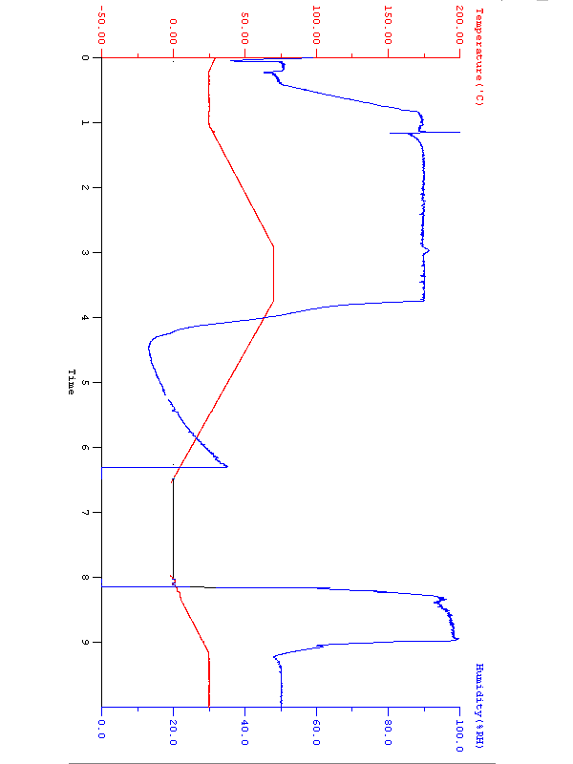

Environment
Temperature & Humidity Cycle Test(Run QAPluse 5.4)

Environment

Temperature & Humidity Cycle Test(Run QAPluse 5.4)

