PCM-3336
Environment Test Report

Release Date : Dec. 24, 1999

__________ __________ __________ __________

Issue Stamp QA Manager QE Manager Test Engineer

Environment
Model Name : PCM-3336
Test Date : 99-12-17
Test Site : AAEON QE Dept.
Performed by : George Hsin
Test Standard :
Select | NO. |  | Description
√ | IEC 68-2-30 |  | Test DB : Damp Heat Test
√ | IEC 68-2-61 |  | Test Z/ABD : Climatic Sequence Test
Testing Item :
Temperature & Humidity Cycle
Test Temperature & Humidity Power On/Off Test
Additional Test Peripheral :
Configuration |  | Model
Test Software |  | QAPluse/FE V5.29
Test Fixture |  | Power on/off(110V) Fixture
Testing Equipment :
Programmable Temperature & Humidity Chamber
Model : Ths-D4L+-100
S/N : 1241
Date of Calibration : 07-10-1998
Sample Configuration & Quantity Under Test :
Use PCM-3336 Single Board with the following options installed .
1.CPU : Ali M6117C
2.DRAM : ON Board 4MB(V53C518160AK50 EDO)
3.Chipset : Ali M6117C
4.VGA Chipset : C&T F65545 B2
5.I/O Chipset : ITE IT8661
Test Result :
Standard | Description |  |  | Result
IEC 68-2-30 | Temperature & Humidity Power On/Off Test |  |  | Pass
IEC 68-2-61 | Temperature&HumidityCycle Test(Run QAPluse/FE V5.29) |  |  | Pass

Environment
Temperature & Humidity Power On/Off Test

Environment

Temperature & Humidity Power On/Off Test

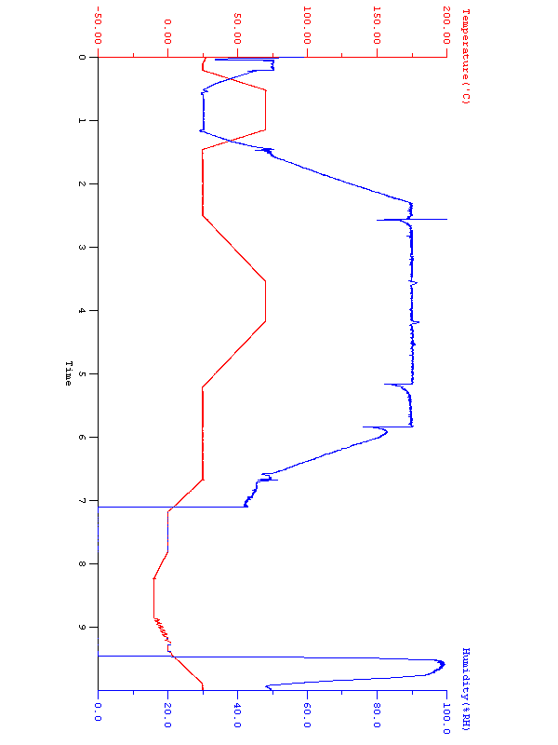

Environment
Temperature & Humidity Cycle Test(Run AMIDIAG 5.11)

Environment
Temperature & Humidity Cycle Test(Run AMIDIAG 5.11)
