AAEON Technology INC.

ISO-9001/ISO-14001 Certified

Industrial Automation PCs

MB-662
Environment Test Report

Release Date : DEC/29/2000

__________ __________ __________ __________

Issue Stamp QA Manager QE Manager Test Engineer

Environment
Model Name : MB-662 Rev.A0.1
Test Date : 12-27-2000
Test Site : AAEON QE Dept.
Performed by : Milo Wang
Test Standard :
Select | NO. |  | Description
√ | IEC 68-2-30 |  | Test DB:Damp Heat Test
√ | IEC 68-2-61 |  | Test Z/ABD : Climatic Sequence Test
Testing Item :
Temperature & Humidity Cycle
Temperature & Humidity Power On/Off Test
Additional Test Peripheral :
Configuration |  | Model
Test Software |  | QAPlus/FE V5.5
Test Fixture |  | Power on/off(110V) Fixture
Testing Equipment :
Programmable Temperature & Humidity Chamber
Model : Ths-D4L+-100
S/N : 1241
Date of Calibration : 07-10-1998
Sample Configuration & Quantity Under Test :
Use MB-662 Rev.A0.1 LPX Board
1.CPU : Intel PentiumⅢ 600MHz
2.DRAM : 64MB(HY57V168010D TC-10S)
3.Chipset : Intel FW82443BX/ FW82371EB
4.VGA Chipset : C&T B69000
5.I/O Chipset :ITE IT8661F
6.BIOS Version:1.0 (12/21/2000)
Test Result :
Standard | Description |  |  | Result
IEC 68-2-30 | Temperature & Humidity Power On/Off Test |  |  | Pass
IEC 68-2-61 | Temperature & Humidity Cycle Test(Run QAPlus/FE V5.5) |  |  | Pass

Environment
Temperature & Humidity Cycle Test(Run QAPlus/FE V5.5)

Environment
Temperature & Humidity Cycle Test(Run QAPlus/FE V5.5)

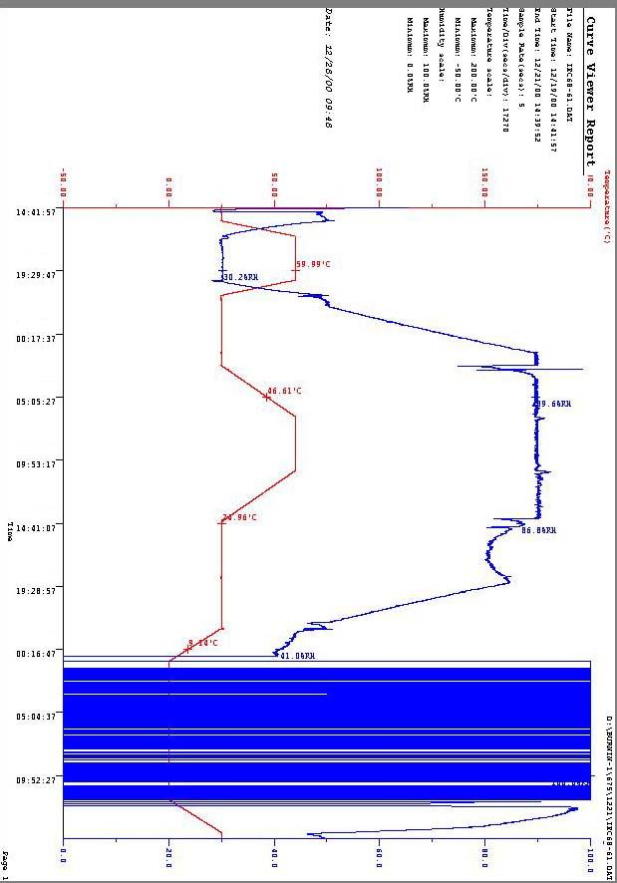

Environment
Temperature & Humidity Power On/Off Test

Environment
Temperature & Humidity Power On/Off Test

