**BOXER-6839-CFL**

Fanless Embedded Box PC

**User’s Manual 1st Ed**

##### Copyright Notice

This document is copyrighted, 2025. All rights are reserved. The original manufacturer reserves the right to make improvements to the products described in this manual at any time without notice.

No part of this manual may be reproduced, copied, translated, or transmitted in any form or by any means without the prior written permission of the original manufacturer. Information provided in this manual is intended to be accurate and reliable. However, the original manufacturer assumes no responsibility for its use, or for any infringements upon the rights of third parties that may result from its use.

The material in this document is for product information only and is subject to change without notice. While reasonable efforts have been made in the preparation of this document to assure its accuracy, AAEON assumes no liabilities resulting from errors or omissions in this document, or from the use of the information contained herein.

AAEON reserves the right to make changes in the product design without notice to its users.

##### Acknowledgement

All other product name or trademarks are properties of their respective owners.

* Microsoft Windows® is a registered trademark of Microsoft Corp.
* Intel®, Pentium®, Celeron®, and Xeon®are registered trademarks of Intel Corporation
* Intel Core™ is a trademark of Intel Corporation

All other product names or trademarks are properties of their respective owners. The publisher of this document does not assume nor imply ownership of any trademarked product not listed herein.

##### Packing List

Before setting up your product, please make sure the following items have been shipped:

|  |  |
| --- | --- |
| **Item** | **Quantity** |
| * BOXER-6839-CFL | 1 |
| * Wallmount bracket | 2 |
| * Screw Package | 1 |
| * 3 Pin DC-In Power Connector | 1 |

If any of these items are missing or damaged, please contact your distributor or sales representative immediately.

##### About this Document

This User’s Manual contains all the essential information, such as detailed descriptions and explanations on the product’s hardware and software features (if any), its specifications, dimensions, jumper/connector settings/definitions, and driver installation instructions (if any), to facilitate users in setting up their product.

Users may refer to the product page at AAEON.com for the latest version of this document.

##### Safety Precautions

Please read the following safety instructions carefully. It is advised that you keep this manual for future references

1. All cautions and warnings on the device should be noted.
2. Make sure the power source matches the power rating of the device.
3. Position the power cord so that people cannot step on it. Do not place anything over the power cord.
4. Always completely disconnect the power before working on the system’s hardware.
5. No connections should be made when the system is powered as a sudden rush of power may damage sensitive electronic components.
6. If the device is not to be used for a long time, disconnect it from the power supply to avoid damage by transient over-voltage.
7. Always disconnect this device from any power supply before cleaning.
8. While cleaning, use a damp cloth instead of liquid or spray detergents.
9. Make sure the device is installed near a power outlet and is easily accessible.
10. Keep this device away from humidity.
11. Place the device on a solid surface during installation to prevent falls.
12. Do not cover the openings on the device to ensure optimal heat dissipation.
13. Watch out for high temperatures when the system is running.
14. Do not touch the heat sink or heat spreader when the system is running
15. Never pour any liquid into the openings. This could cause fire or electric shock.
16. As most electronic components are sensitive to static electrical charge, be sure to ground yourself to prevent static charge when installing the internal components. Use a grounding wrist strap and contain all electronic components in any static-shielded containers.
17. If any of the following situations arises, please the contact our service personnel:
18. Damaged power cord or plug
19. Liquid intrusion to the device
20. Exposure to moisture
21. Device is not working as expected or in a manner as described in this manual
22. The device is dropped or damaged
23. Any obvious signs of damage displayed on the device
24. Do not leave this device in an uncontrolled environment with temperatures beyond the device’s permitted storage temperatures (see chapter 1) to prevent damage.
25. Do NOT disassemble the motherboard so as not to damage the system or void your warranty.
26. If the thermal pad had been damaged, please contact AAEON's salesperson to purchase a new one. Do NOT use those of other brands.
27. The Hex Cylinder Coppers on the front panel are not removable.
28. Repeatedly assemble and disassemble the system may cause damages to the exterior paint and surface and screw holes.
29. Use the right size screwdriver.
30. Use the screwdriver correctly to remove screws from the system.

##### FCC Statement

|  |  |
| --- | --- |
|  | This device complies with Part 15 FCC Rules. Operation is subject to the following two conditions: (1) this device may not cause harmful interference, and (2) this device must accept any interference received including interference that may cause undesired operation. |

***Caution:***

*There is a danger of explosion if the battery is incorrectly replaced. Replace only with the same or equivalent type recommended by the manufacturer. Dispose of used batteries according to the manufacturer’s instructions and your local government’s recycling or disposal directives.*

***Attention:***

*Il y a un risque d’explosion si la batterie est remplacée de façon incorrecte.*

*Ne la remplacer qu’avec le même modèle ou équivalent recommandé par le constructeur. Recycler les batteries usées en accord avec les instructions du fabricant et les directives gouvernementales de recyclage.*

##### China RoHS Requirements (CN)

|  |  |  |  |  |  |  |
| --- | --- | --- | --- | --- | --- | --- |
| 产品中有毒有害物质或元素名称及含量 | | | | | | |
| AAEON System | QO4-381 Rev.A2 | | | | | |
| 部件名称 | 有毒有害物质或元素 | | | | | |
| 铅  (Pb) | 汞  (Hg) | 镉  (Cd) | 六价铬(Cr(VI)) | 多溴联苯(PBB) | 多溴二苯醚(PBDE) |
| 印刷电路板  及其电子组件 | × | ○ | ○ | ○ | ○ | ○ |
| 外部信号  连接器及线材 | × | ○ | ○ | ○ | ○ | ○ |
| 外壳 | ○ | ○ | ○ | ○ | ○ | ○ |
| 中央处理器  与内存 | × | ○ | ○ | ○ | ○ | ○ |
| 硬盘 | × | ○ | ○ | ○ | ○ | ○ |
| 液晶模块 | × | ○ | ○ | ○ | ○ | ○ |
| 光驱 | × | ○ | ○ | ○ | ○ | ○ |
| 触控模块 | × | ○ | ○ | ○ | ○ | ○ |
| 电源 | × | ○ | ○ | ○ | ○ | ○ |
| 电池 | × | ○ | ○ | ○ | ○ | ○ |
| 本表格依据 SJ/T 11364 的规定编制。  ○：表示该有毒有害物质在该部件所有均质材料中的含量均在GB/T 26572标准规定的限量要求以下。  ×：表示该有害物质的某一均质材料超出了GB/T 26572的限量要求，然而该部件仍符合欧盟指令2011/65/EU的规范。  环保使用期限(EFUP (Environmental Friendly Use Period)) : 10年  备注：  一、此产品所标示之环保使用期限，系指在一般正常使用状况下。  二、上述部件物质中央处理器、内存、硬盘、光驱、电源为选购品。  三、上述部件物质液晶模块、触控模块仅一体机产品适用。 | | | | | | |

##### China RoHS Requirement (EN)

|  |  |  |  |  |  |  |
| --- | --- | --- | --- | --- | --- | --- |
| Name and content of hazardous substances in product | | | | | | |
| AAEON System | QO4-381 Rev.A2 | | | | | |
| Part Name | Hazardous Substances | | | | | |
| 铅  (Pb) | 汞  (Hg) | 镉  (Cd) | 六价铬(Cr(VI)) | 多溴联苯(PBB) | 多溴二苯醚(PBDE) |
| PCB Assemblies | × | ○ | ○ | ○ | ○ | ○ |
| Connector and Cable | × | ○ | ○ | ○ | ○ | ○ |
| Chassis | ○ | ○ | ○ | ○ | ○ | ○ |
| CPU and Memory | × | ○ | ○ | ○ | ○ | ○ |
| Hard Disk | × | ○ | ○ | ○ | ○ | ○ |
| LCD Modules | × | ○ | ○ | ○ | ○ | ○ |
| CD-ROM/DVD-ROM | × | ○ | ○ | ○ | ○ | ○ |
| Touch Modules | × | ○ | ○ | ○ | ○ | ○ |
| Power | × | ○ | ○ | ○ | ○ | ○ |
| Battery | × | ○ | ○ | ○ | ○ | ○ |
| The table is prepared in accordance with the provisions of SJ/T 11364.  ○：Indicates that said hazardous substance contained in all of the homogenous materials for this product is below the limit requirement of GB/T 26572.  ×：Indicates that said hazardous substance contained in at least one of the homogenous materials used for this part is above the limit requirement of GB/T 26572. But this product still be compliance with 2011/65/EU Directive (allowed with 2011/65/EU Annex III of RoHS exemption with number 6(c),7(a),7(c)-1).  EFUP (Environment Friendly Use Period) value: 10 years.  Notes：  1. This product defined period of use is under normal condition.  2. In above part, CPU/Memory/ Hard Disk/CD-ROM/DVD-ROM/ Power are optional.  3. In above part, LCD Modules/ Touch Modules are for all-in-one product model. | | | | | | |

##### Table of Contents

[Chapter 1 - Product Specifications 1](#_Toc67469027)

[1.1 Specifications 2](#_Toc67469028)

[Chapter 2 – Hardware Information 4](#_Toc67469029)

[2.1 BOXER-6839-CFL Dimensions 5](#_Toc67469030)

[2.2 Jumpers and Connectors 8](#_Toc67469031)

[2.3 List of Jumpers 9](#_Toc67469032)

[2.3.1 Setting Jumpers 9](#_Toc67469033)

[2.3.2 Auto Power Button Selection (AT/ATX Mode) (JP19) 10](#_Toc67469034)

[2.3.3 CMOS Control Selection (JP24) 10](#_Toc67469035)

[2.4 List of Connectors 11](#_Toc67469036)

[2.4.1 Pheonix Connector Power Input (CN2) 12](#_Toc67469037)

[2.4.2 SPI Flash Port (CN7) 13](#_Toc67469038)

[2.4.3 PCIe [x4] Slot (CN8) 13](#_Toc67469039)

[2.4.4 LAN (RJ-45) + Dual USB3.2 Gen 1 (CN14) 16](#_Toc67469040)

[2.4.5 LAN (RJ-45) + Dual USB3.2 Gen 1 (CN15) 18](#_Toc67469041)

[2.4.6 Audio Connector (CN18) 19](#_Toc67469042)

[2.4.7 Digital IO Port (CN43) 20](#_Toc67469043)

[2.4.8 USB2.0 Wafer BOX (5P Pitch: 1.25mm) (CN 45,71,72) 21](#_Toc67469044)

[2.4.9 COM5 + COM6 Connector RS232/RS422/RS485 (CN49) 21](#_Toc67469045)

[2.4.10 COM1 + COM2 Connector RS232/RS422/RS485 (CN60) 22](#_Toc67469046)

[2.4.11 COM3 + COM4 Connector RS232/RS422/RS485 (CN62) 24](#_Toc67469047)

[2.4.12 LAN (RJ-45) + Dual USB3.2 Gen 1 (CN73) 25](#_Toc67469048)

[2.4.13 LAN (RJ-45) + Dual USB3.2 Gen 1 (CN74) 26](#_Toc67469049)

[2.4.14 HDMI Port (CN75) 28](#_Toc67469050)

[2.4.15 HDMI Port (CN76) 29](#_Toc67469051)

[2.4.16 LPC Port (LPC1) 30](#_Toc67469052)

[2.4.17 Mini Card Slot (Full-Sized) (PCIE1) 31](#_Toc67469053)

[2.4.18 Mini Card Slot with mSATA (Full Sized) (PCIE2) 33](#_Toc67469054)

[2.4.19 SATA PWR (PWR 1,2) 36](#_Toc67469055)

[2.4.20 SATA Port (SATA 3,4) 36](#_Toc67469056)

[2.4.21 SIM Slot (SIM1) 37](#_Toc67469057)

[2.5 CPU Installation 38](#_Toc67469058)

[2.6 Expansion Card Installation 40](#_Toc67469059)

[2.7 2.5” SATA Drive Installation 42](#_Toc67469060)

[2.8 Wallmount Assembly 44](#_Toc67469061)

[Chapter 3 - AMI BIOS Setup 45](#_Toc67469062)

[3.1 System Test and Initialization 46](#_Toc67469063)

[3.2 AMI BIOS Setup 47](#_Toc67469064)

[3.3 Setup Submenu: Main 48](#_Toc67469065)

[3.4 Setup Submenu: Advanced 49](#_Toc67469066)

[3.4.1 Advanced: Trusted Computing 50](#_Toc67469067)

[3.4.2 Advanced: CPU Configuration 52](#_Toc67469068)

[3.4.3 Advanced: PCH-FW Configuration 54](#_Toc67469069)

[3.4.3.1 Firmware Update Configuration 55](#_Toc67469070)

[3.4.3.2 PTT Configuration 56](#_Toc67469071)

[3.4.4 Advanced: SATA Configuration 57](#_Toc67469072)

[3.4.5 Advanced: USB Configuration 58](#_Toc67469073)

[3.4.6 Advanced: Hardware Monitor 59](#_Toc67469074)

[3.4.7 Advanced: SIO Configuration 60](#_Toc67469075)

[3.4.7.1 Serial Port 1 Configuration 61](#_Toc67469076)

[3.4.7.2 Serial Port 2 Configuration 62](#_Toc67469077)

[3.4.7.3 Serial Port 3 Configuration 63](#_Toc67469078)

[3.4.7.4 Serial Port 4 Configuration 64](#_Toc67469079)

[3.4.7.5 Serial Port 5 Configuration 65](#_Toc67469080)

[3.4.7.6 Serial Port 6 Configuration 66](#_Toc67469081)

[3.4.8 Advanced: Network Stack Configuration 67](#_Toc67469082)

[3.4.9 Advanced: Digital IO Port Configuration 70](#_Toc67469083)

[3.4.10 Advanced: Power Management 71](#_Toc67469084)

[3.5 Setup Submenu: Chipset 73](#_Toc67469085)

[3.5.1 Chipset: System Agent (SA) Configuration 74](#_Toc67469086)

[3.5.2 Chipset: PCH-IO Configuration 76](#_Toc67469087)

[3.6 Setup Submenu: Security 78](#_Toc67469088)

[3.6.1 Security: Secure Boot 79](#_Toc67469089)

[3.6.1.1 Key Management 81](#_Toc67469090)

[3.7 Setup Submenu: Boot 85](#_Toc67469091)

[3.8 Setup Submenu: Save & Exit 86](#_Toc67469092)

[Chapter 4 – Drivers Installation 87](#_Toc67469093)

[4.1 Drivers Download and Installation 88](#_Toc67469094)

[Appendix A - Watchdog Timer Programming 90](#_Toc67469095)

[A.1 Watchdog Timer Initial Program 91](#_Toc67469096)

[Appendix B - I/O Information 96](#_Toc67469097)

[B.1 I/O Address Map 97](#_Toc67469098)

[B.2 IRQ Mapping Chart 99](#_Toc67469099)

[B.3 Memory Address Map 111](#_Toc67469100)

[Appendix C - Digital I/O Ports 112](#_Toc67469101)

[C.1 Electrical Specifications for Digital I/O Ports 113](#_Toc67469102)

[C.2 DIO Programming 114](#_Toc67469103)

[C.3 Digital I/O Register 115](#_Toc67469104)

[C.4 Digital I/O Sample Program 116](#_Toc67469105)

[Appendix D – Glue Removal Procedure 122](#_Toc67469106)

[D.1 Removing Glue from Your System 123](#_Toc67469107)

**Chapter 1**

# Chapter 1 - Product Specifications

## 1.1 Specifications

| **System** |  |
| --- | --- |
| **CPU** | Intel® Xeon® E-2124G  Intel® i9-9900T  Intel® i7-9700TE  Intel® i7-8700T  Intel® i5-8500T  Intel® i3-8100T  Pentium® G5400T  Celeron® G4900T |
| **Chipset** | C246 |
| **System Memory** | DDR4-2666 SO-DIMM slot x 2  Up to 64GB, ECC or Non-ECC Supported |
| **Display Interface** | HDMI x 2 |
| **Storage Device** | 2.5” SATA HDD/SSD Bay x 2 |
| **Ethernet** | RJ-45 x 4 for GbE LAN (i211 x 3, i219 x 1) |
| **I/O** | HDMI x 2  RJ-45 x 4 for GbE LAN (i211 x 3, i219 x 1)  USB3.2 Gen 1 x 8  DB-9 x 6 for RS-232/422/485  Audio x 1 (MIC-in, Line-out)  DB-15 for DIO 8 bit x 1  3-pin 10~35V Power Input x 1  Power Button x 1  Remote Power switch x 1  Reset Button x 1 |
| **Expansion** | Full-size Mini Card x 1 (PCIe)  Full-size Mini Card x 1 (PCIe/mSATA switch by BIOS, Default: mSATA)  SIM slot x 1  PCI/PCI Express slot configuration:  Riser card type 1: PCIe[x4] slot x 1 & PCIe[x1] x 1  Riser card type 2: PCIe[x4] slot x 1 & PCI x 1  Riser card type 3: PCI x 2 |
| **Indicator** | HDD LED x 1  System LED x 1 |
| **OS Support** | Windows® 10 64-bit  Linux Ubuntu 20.04 |

|  |  |
| --- | --- |
| **Power Supply** |  |
| **Power Requirement** | 3-pin Phoenix DC Input 10~35V |

|  |  |
| --- | --- |
| **Mechanical** |  |
| **Mounting** | Wallmount |
| **Dimensions (W x H x D)** | 264mm x 156mm x 125mm |
| **Gross Weight** | 13.2 lbs. (6.0 kg) |
| **Net Weight** | 9.9 lbs. (4.5 kg) |

|  |  |
| --- | --- |
| **Environmental** |  |
| **Operating Temperature** | -4°F ~131°F (-20°C ~ 55°C) with 0.5 m/s airflow (with TDP ≦ 35W CPU)  -4°F~113°F (-20°C ~45°C) with 0.5 m/s airflow (with TDP > 35W CPU) |
| **Storage Temperature** | -49°F ~ 176°F (-45°C ~ 80°C) |
| **Storage Humidity** | 5~95% @ 40°C, non-condensing |
| **Anti-Vibration** | 5 Grms/ 5 ~ 500Hz/ operation –SSD |
| **Certification** | CE/FCC class A |
| **Drop Testing** | 76 cm (1 corner, 3 edge, 6 surface) |
| **Shock** | With SSD: 50G at wallmount, half-sine, 11ms |

**Chapter 2**

# Chapter 2 – Hardware Information

## 2.1 BOXER-6839-CFL Dimensions

****

****

****

****

****

****



## 2.2 Jumpers and Connectors

**Note:** Board dimensions are 225mm x 151.5mm x 1.8mm

**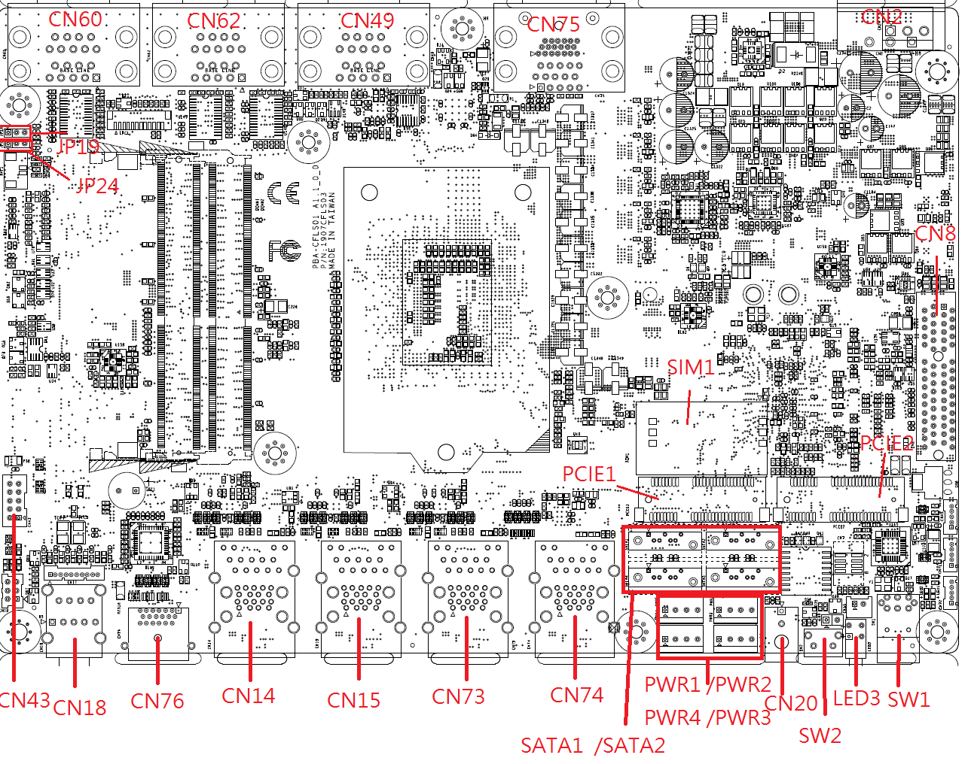**

## 2.3 List of Jumpers

Please refer to the table below for all of the system’s jumpers that you can configure for your application.

|  |  |
| --- | --- |
| **Label** | **Function** |
| JP19 | Auto-Power Button Selection (AT/ATX Mode) |
| JP24 | CMOS Control Selection (Clear CMOS) |

### 2.3.1 Setting Jumpers

The BOXER-6839-CFL comes with several jumpers which allow you to configure the system by either setting the jumper to “open” or “closed”; or by selecting certain pins. A closed jumper has two pins connected with a jumper clip, while an open jumper has no pins connected.

For jumpers with multiple pins, this guide uses “pins A-B” to notate which pins should be connected by a jumper clip. For example, “pins 1-2” means you should connect pins 1 and 2, while “pins 2-3” means you should connect pins 2 and 3.

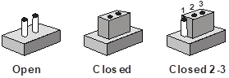

A pair of needle-nose pliers may be helpful when working with jumpers.

If you have any questions about how best to configure the system for your application, contact your AAEON representative or visit our website to talk with our support team.

### 2.3.2 Auto Power Button Selection (AT/ATX Mode) (JP19)

|  |  |
| --- | --- |
| **B1-2**  ATX Mode **(default)**  Auto Power Disabled | **B2-3**  AT Mode/  Auto Power Enabled |

**Note:** Disable Auto Power Button JP19 (1-2) requires user to use power button JP19 (1-2) to power on the system.

### 2.3.3 CMOS Control Selection (JP24)

|  |  |
| --- | --- |
| Y1-2  Normal (**Default**) | Y2-3  Clear CMOS |

## 2.4 List of Connectors

Please refer to the table below for all of the system’s connectors that you can configure for your application

| **Label** | **Function** |
| --- | --- |
| **BAT1** | RTC Battery |
| **CN2** | Phoenix Connector Power Input |
| **CN7** | SPI flash port |
| **CN8** | PCIe [x4] Slot |
| **CN14** | LAN+USB3.2 Gen 1 x2 Connector |
| **CN15** | LAN+USB3.2 Gen 1 x2 Connector |
| **CN18** | Audio Connector |
| **CN20** | Remote Button |
| **CN43** | Digital IO Port |
| **CN45** | USB2.0 (HEADER) |
| **CN49** | COM5+COM6 Connector RS232/RS422/RS485 |
| **CN60** | COM1+COM2 Connector RS232/RS422/RS485 |
| **CN62** | COM3+COM4 Connector RS232/RS422/RS485 |
| **CN71** | USB2.0 (HEADER) |
| **CN72** | USB2.0 (HEADER) |
| **CN73** | LAN+USB3.2 Gen 1 x2 Connector |
| **CN74** | LAN+USB3.2 Gen 1 x2 Connector |
| **CN75** | HDMI Port |
| **CN76** | HDMI Port |
| **LPC1** | LPC Port |
| **PCIE1** | Mini Card slot (full-sized) |
| **PCIE2** | Mini Card slot with mSATA (full-sized) |
| **PWR1** | SATA PWR Connector |
| **PWR2** | SATA PWR Connector |
| **SATA3** | SATA3 |
| **SATA4** | SATA4 |
| **SIM1** | SIM Card Slot |
| **SW1** | Power Button |
| **SW2** | Reset Switch |

### 2.4.1 Pheonix Connector Power Input (CN2)

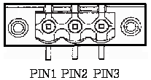

|  |  |  |  |
| --- | --- | --- | --- |
| **Pin** | **Signal** | **Signal Type** | **Signal Level** |
| **1** | VIN | PWR | +10V~+35V |
| **2** | GND | GND |  |
| **3** | GND\_EARTH |  |  |

### 2.4.2 SPI Flash Port (CN7)

|  |  |  |  |
| --- | --- | --- | --- |
| **Pin** | **Signal** | **Signal Type** | **Signal Level** |
| **1** | SPI\_MISO | OUT |  |
| **2** | GND | GND |  |
| **3** | SPI\_CLK | IN |  |
| **4** | +3.3VSB | PWR | +3.3V |
| **5** | SPI\_MOSI | IN |  |
| **6** | SPI\_CS | IN |  |
| **7** | NC |  |  |
| **8** | NC |  |  |

### 2.4.3 PCIe [x4] Slot (CN8)

**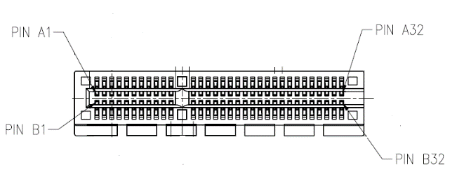**

| **Pin** | **Signal** | **Signal Type** | **Signal Level** |
| --- | --- | --- | --- |
| **A1** | PRSNT1# | I/O |  |
| **A2** | +12V | PWR | +V12S |
| **A3** | +12V | PWR | +V12S |
| **A4** | GND | GND |  |
| **A5** | PCIE\_TXN5 | DIFF |  |
| **A6** | PCIE\_TXP5 | DIFF |  |
| **A7** | PCIE\_RXN5 | DIFF |  |
| **A8** | PCIE\_RXP5 | DIFF |  |
| **A9** | +3.3V | PWR | +V3.3S |
| **A10** | +3.3V | PWR | +V3.3S |
| **A11** | PERST# | I/O |  |
| **A12** | GND | GND |  |
| **A13** | PCIE\_x4SLOT\_CLK | DIFF |  |
| **A14** | PCIE\_x4SLOT\_CLK# | DIFF |  |
| **A15** | GND | GND |  |
| **A16** | PCIE\_RXP24 | DIFF |  |
| **A17** | PCIE\_RXN24 | DIFF |  |
| **A18** | GND | GND |  |
| **A19** | NC |  |  |
| **A20** | GND | GND |  |
| **A21** | PCIE\_RXP23 | DIFF |  |
| **A22** | PCIE\_RXN23 | DIFF |  |
| **A23** | GND | GND |  |
| **A24** | GND | GND |  |
| **A25** | PCIE\_RXP22 | DIFF |  |
| **A26** | PCIE\_RXP22 | DIFF |  |
| **A27** | GND | GND |  |
| **A28** | GND | GND |  |
| **A29** | PCIE\_RXP21 | DIFF |  |
| **A30** | PCIE\_RXN21 | DIFF |  |
| **A31** | GND | GND |  |
| **A32** | NC |  |  |
| **B1** | +12V | PWR | +V12S |
| **B2** | +12V | PWR | +V12S |
| **B3** | +12V | PWR | +V12S |
| **B4** | GND | GND |  |
| **B5** | SMB\_CLK | I/O |  |
| **B6** | SMB\_DATA | I/O |  |
| **B7** | GND | GND |  |
| **B8** | +V3.3S | PWR | +V3.3S |
| **B9** | NC |  |  |
| **B10** | 3.3Vaux | PWR | +V3.3A |
| **B11** | WAKE# | I/O |  |
| **B12** | NC |  |  |
| **B13** | GND | GND |  |
| **B14** | PCIE\_TXP24 | DIFF |  |
| **B15** | PCIE\_TXN24 | DIFF |  |
| **B16** | GND | GND |  |
| **B17** | PRSNT | I/O |  |
| **B18** | GND | GND |  |
| **B19** | PCIE\_TXP23 | DIFF |  |
| **B20** | PCIE\_TXN23 | DIFF |  |
| **B21** | GND | GND |  |
| **B22** | GND | GND |  |
| **B23** | PCIE\_TXP22 | DIFF |  |
| **B24** | PCIE\_TXN22 | DIFF |  |
| **B25** | GND | GND |  |
| **B26** | GND | GND |  |
| **B27** | PCIE\_TXP21 | DIFF |  |
| **B28** | PCIE\_TXN21 | DIFF |  |
| **B29** | GND | GND |  |
| **B30** | NC |  |  |
| **B31** | PRSNT | I/O |  |
| **B32** | GND | GND |  |

### 2.4.4 LAN (RJ-45) + Dual USB3.2 Gen 1 (CN14)

**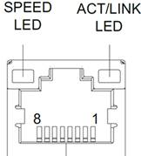**

| **Pin** | **Signal** | **Signal Type** | **Signal Level** |
| --- | --- | --- | --- |
| **1** | MDI0+ | DIFF |  |
| **2** | MDI0- | DIFF |  |
| **3** | MDI1+ | DIFF |  |
| **4** | MDI2+ | DIFF |  |
| **5** | MDI2- | DIFF |  |
| **6** | MDI1- | DIFF |  |
| **7** | MDI3+ | DIFF |  |
| **8** | MDI3- | DIFF |  |

USB_0723

| **Pin** | **Signal** | **Signal Type** | **Signal Level** |
| --- | --- | --- | --- |
| **1** | +5VSB | PWR | +5V |
| **2** | USB7\_D- | DIFF |  |
| **3** | USB7\_D+ | DIFF |  |
| **4** | GND | GND |  |
| **5** | USB7\_SSRX− | DIFF |  |
| **6** | USB7\_SSRX+ | DIFF |  |
| **7** | GND | GND |  |
| **8** | USB7\_SSTX− | DIFF |  |
| **9** | USB7\_SSTX+ | DIFF |  |
| **10** | +5VSB | PWR | +5V |
| **11** | USB8\_D- | DIFF |  |
| **12** | USB8\_D+ | DIFF |  |
| **13** | GND | GND |  |
| **14** | USB8\_SSRX− | DIFF |  |
| **15** | USB8\_SSRX+ | DIFF |  |
| **16** | GND | GND |  |
| **17** | USB8\_SSTX− | DIFF |  |
| **18** | USB8\_SSTX+ | DIFF |  |

### 2.4.5 LAN (RJ-45) + Dual USB3.2 Gen 1 (CN15)

****

| **Pin** | **Signal** | **Signal Type** | **Signal Level** |
| --- | --- | --- | --- |
| **1** | MDI0+ | DIFF |  |
| **2** | MDI0- | DIFF |  |
| **3** | MDI1+ | DIFF |  |
| **4** | MDI2+ | DIFF |  |
| **5** | MDI2- | DIFF |  |
| **6** | MDI1- | DIFF |  |
| **7** | MDI3+ | DIFF |  |
| **8** | MDI3- | DIFF |  |

USB_0723

| **Pin** | **Signal** | **Signal Type** | **Signal Level** |
| --- | --- | --- | --- |
| **1** | +5VSB | PWR | +5V |
| **2** | USB5\_D- | DIFF |  |
| **3** | USB5\_D+ | DIFF |  |
| **4** | GND | GND |  |
| **5** | USB5\_SSRX− | DIFF |  |
| **6** | USB5\_SSRX+ | DIFF |  |
| **7** | GND | GND |  |
| **8** | USB5\_SSTX− | DIFF |  |
| **9** | USB5\_SSTX+ | DIFF |  |
| **10** | +5VSB | PWR | +5V |
| **11** | USB6\_D- | DIFF |  |
| **12** | USB6\_D+ | DIFF |  |
| **13** | GND | GND |  |
| **14** | USB6\_SSRX− | DIFF |  |
| **15** | USB6\_SSRX+ | DIFF |  |
| **16** | GND | GND |  |
| **17** | USB6\_SSTX− | DIFF |  |
| **18** | USB6\_SSTX+ | DIFF |  |

### 2.4.6 Audio Connector (CN18)

**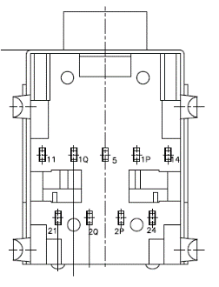**

| **Pin** | **Signal** | **Signal Type** | **Signal Level** |
| --- | --- | --- | --- |
| **5** | AUD\_GND | GND |  |
| **24** | LOUT\_L | OUT |  |
| **21** | LOUT\_R | OUT |  |
| **2P** | HP\_DET\_3 | IN |  |
| **2Q** | HP\_DET\_4 | IN |  |
| **14** | MIC\_L | IN |  |
| **11** | MIC\_R | IN |  |
| **1P** | HP\_DET\_1 | IN |  |
| **1Q** | HP\_DET2 | IN |  |

### 2.4.7 Digital IO Port (CN43)

**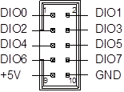**

|  |  |  |  |
| --- | --- | --- | --- |
| **Pin** | **Signal** | **Signal Type** | **Signal Level** |
| **1** | DIO0 | I/O | +5V |
| **2** | DIO1 | I/O | +5V |
| **3** | DIO2 | I/O | +5V |
| **4** | DIO3 | I/O | +5V |
| **5** | DIO4 | I/O | +5V |
| **6** | DIO5 | I/O | +5V |
| **7** | DIO6 | I/O | +5V |
| **8** | DIO7 | I/O | +5V |
| **9** | +5V | PWR | +5V |
| **10** | GND | GND |  |

### 2.4.8 USB2.0 Wafer BOX (5P Pitch: 1.25mm) (CN 45,71,72)

**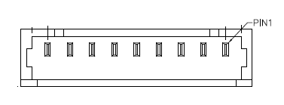**

|  |  |  |  |
| --- | --- | --- | --- |
| **Pin** | **Signal** | **Signal Type** | **Signal Level** |
| **1** | +5V | GND | +5V |
| **2** | USBD- | DIFF |  |
| **3** | USBD+ | DIFF |  |
| **4** | GND | GND |  |
| **5** | GND | GND |  |

### 2.4.9 COM5 + COM6 Connector RS232/RS422/RS485 (CN49)

**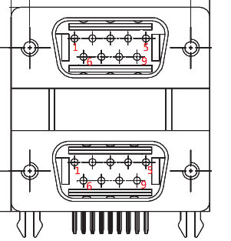**

| **Pin** | **Signal** | **Signal Type** | **Signal Level** |
| --- | --- | --- | --- |
| **Top Port (COM5)** | | | |
| **1** | DCD5 | IN |  |
| **2** | RX5 | IN |  |
| **3** | TX5 | OUT | ±9V |
| **4** | DTR5 | OUT | ±9V |
| **5** | GND | GND |  |
| **6** | DSR5 | IN |  |
| **7** | RTS5 | OUT | ±9V |
| **8** | CTS5 | IN |  |
| **9** | RI5 | IN |  |
| **Bottom Port (COM6)** | | | |
| **10** | DCD6 | IN |  |
| **11** | RX6 | IN |  |
| **12** | TX6 | OUT | ±9V |
| **13** | DTR6 | OUT | ±9V |
| **14** | GND | GND |  |
| **15** | DSR6 | IN |  |
| **16** | RTS6 | OUT | ±9V |
| **17** | CTS6 | IN |  |
| **18** | RI6 | IN |  |

### 2.4.10 COM1 + COM2 Connector RS232/RS422/RS485 (CN60)

****

| **Pin** | **Signal** | **Signal Type** | **Signal Level** |
| --- | --- | --- | --- |
| **Top Port (COM 1)** | | | |
| **1** | DCD1 | IN |  |
| **2** | RX1 | IN |  |
| **3** | TX1 | OUT | ±9V |
| **4** | DTR1 | OUT | ±9V |
| **5** | GND | GND |  |
| **6** | DSR1 | IN |  |
| **7** | RTS1 | OUT | ±9V |
| **8** | CTS1 | IN |  |
| **9** | RI1 | IN |  |
| **Bottom Port (COM2)** | | | |
| **10** | DCD2 | IN |  |
| **11** | RX2 | IN |  |
| **12** | TX2 | OUT | ±9V |
| **13** | DTR2 | OUT | ±9V |
| **14** | GND | GND |  |
| **15** | DSR2 | IN |  |
| **16** | RTS2 | OUT | ±9V |
| **17** | CTS2 | IN |  |
| **18** | RI2 | IN |  |

### 2.4.11 COM3 + COM4 Connector RS232/RS422/RS485 (CN62)

****

|  |  |  |  |
| --- | --- | --- | --- |
| **Pin** | **Signal** | **Signal Type** | **Signal Level** |
| **Top Port (COM3)** | | | |
| **1** | DCD3 | IN |  |
| **2** | RX3 | IN |  |
| **3** | TX3 | OUT | ±9V |
| **4** | DTR3 | OUT | ±9V |
| **5** | GND | GND |  |
| **6** | DSR3 | IN |  |
| **7** | RTS3 | OUT | ±9V |
| **8** | CTS3 | IN |  |
| **9** | RI3 | IN |  |
| **Bottom Port (COM4)** | | | |
| **10** | DCD4 | IN |  |
| **11** | RX4 | IN |  |
| **12** | TX4 | OUT | ±9V |
| **13** | DTR4 | OUT | ±9V |
| **14** | GND | GND |  |
| **15** | DSR4 | IN |  |
| **16** | RTS4 | OUT | ±9V |
| **17** | CTS4 | IN |  |
| **18** | RI4 | IN |  |

### 2.4.12 LAN (RJ-45) + Dual USB3.2 Gen 1 (CN73)

****

| **Pin** | **Signal** | **Signal Type** | **Signal Level** |
| --- | --- | --- | --- |
| **1** | MDI0+ | DIFF |  |
| **2** | MDI0- | DIFF |  |
| **3** | MDI1+ | DIFF |  |
| **4** | MDI2+ | DIFF |  |
| **5** | MDI2- | DIFF |  |
| **6** | MDI1- | DIFF |  |
| **7** | MDI3+ | DIFF |  |
| **8** | MDI3- | DIFF |  |

USB_0723

| **Pin** | **Signal** | **Signal Type** | **Signal Level** |
| --- | --- | --- | --- |
| **1** | +5VSB | PWR | +5V |
| **2** | USB3\_D- | DIFF |  |
| **3** | USB3\_D+ | DIFF |  |
| **4** | GND | GND |  |
| **5** | USB3\_SSRX− | DIFF |  |
| **6** | USB3\_SSRX+ | DIFF |  |
| **7** | GND | GND |  |
| **8** | USB3\_SSTX− | DIFF |  |
| **9** | USB3\_SSTX+ | DIFF |  |
| **10** | +5VSB | PWR | +5V |
| **11** | USB4\_D- | DIFF |  |
| **12** | USB4\_D+ | DIFF |  |
| **13** | GND | GND |  |
| **14** | USB4\_SSRX− | DIFF |  |
| **15** | USB4\_SSRX+ | DIFF |  |
| **16** | GND | GND |  |
| **17** | USB4\_SSTX− | DIFF |  |
| **18** | USB4\_SSTX+ | DIFF |  |

### 2.4.13 LAN (RJ-45) + Dual USB3.2 Gen 1 (CN74)

****

| **Pin** | **Signal** | **Signal Type** | **Signal Level** |
| --- | --- | --- | --- |
| **1** | MDI0+ | DIFF |  |
| **2** | MDI0- | DIFF |  |
| **3** | MDI1+ | DIFF |  |
| **4** | MDI2+ | DIFF |  |
| **5** | MDI2- | DIFF |  |
| **6** | MDI1- | DIFF |  |
| **7** | MDI3+ | DIFF |  |
| **8** | MDI3- | DIFF |  |

USB_0723

| **Pin** | **Signal** | **Signal Type** | **Signal Level** |
| --- | --- | --- | --- |
| **1** | +5VSB | PWR | +5V |
| **2** | USB1\_D- | DIFF |  |
| **3** | USB1\_D+ | DIFF |  |
| **4** | GND | GND |  |
| **5** | USB1\_SSRX− | DIFF |  |
| **6** | USB1\_SSRX+ | DIFF |  |
| **7** | GND | GND |  |
| **8** | USB1\_SSTX− | DIFF |  |
| **9** | USB1\_SSTX+ | DIFF |  |
| **10** | +5VSB | PWR | +5V |
| **11** | USB2\_D- | DIFF |  |
| **12** | USB2\_D+ | DIFF |  |
| **13** | GND | GND |  |
| **14** | USB2\_SSRX− | DIFF |  |
| **15** | USB2\_SSRX+ | DIFF |  |
| **16** | GND | GND |  |
| **17** | USB2\_SSTX− | DIFF |  |
| **18** | USB2\_SSTX+ | DIFF |  |

### 2.4.14 HDMI Port (CN75)

**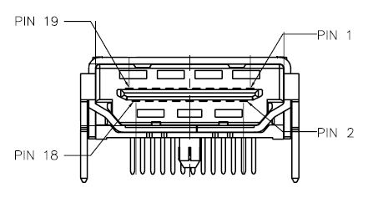**

| **Pin** | **Signal** | **Signal Type** | **Signal Level** |
| --- | --- | --- | --- |
| **1** | HDMI1\_DATA2\_P | OUT |  |
| **2** | GND | GND |  |
| **3** | HDMI1\_DATA2\_N | DIFF |  |
| **4** | HDMI1\_DATA1\_P | DIFF |  |
| **5** | GND | GND |  |
| **6** | HDMI1\_DATA1\_N | DIFF |  |
| **7** | HDMI1\_DATA0\_P | DIFF |  |
| **8** | NC |  |  |
| **9** | HDMI1\_DATA0\_N | DIFF |  |
| **10** | HDMI1\_CLK\_P | DIFF |  |
| **11** | GND | GND |  |
| **12** | HDMI1\_CLK\_N | DIFF |  |
| **13** | NC |  |  |
| **14** | NC |  |  |
| **15** | HDMI1\_SCL | DIFF |  |
| **16** | NC |  |  |
| **17** | HDMI1\_SDA | DIFF |  |
| **18** | +V5S\_HDMI\_CON1 | PWR |  |
| **19** | HDMI1\_HPD | GND |  |

### 2.4.15 HDMI Port (CN76)

****

| **Pin** | **Signal** | **Signal Type** | **Signal Level** |
| --- | --- | --- | --- |
| **1** | HDMI2\_DATA2\_P | DIFF |  |
| **2** | GND | GND |  |
| **3** | HDMI2\_DATA2\_N | DIFF |  |
| **4** | HDMI2\_DATA1\_P | DIFF |  |
| **5** | GND | GND |  |
| **6** | HDMI2\_DATA1\_N | DIFF |  |
| **7** | HDMI2\_DATA0\_P | DIFF |  |
| **8** | NC |  |  |
| **9** | HDMI2\_DATA0\_N | DIFF |  |
| **10** | HDMI2\_CLK\_P | DIFF |  |
| **11** | GND | GND |  |
| **12** | HDMI2\_CLK\_N | DIFF |  |
| **13** | NC |  |  |
| **14** | NC |  |  |
| **15** | HDMI2\_SCL | DIFF |  |
| **16** | HDMI2\_SDA | DIFF |  |
| **17** | GND | GND |  |
| **18** | +V5S\_HDMI\_CON2 | PWR |  |
| **19** | HDMI2\_HPD | GND |  |

### 2.4.16 LPC Port (LPC1)

**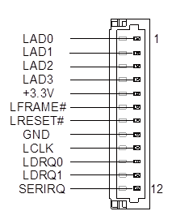**

| **Pin** | **Signal** | **Signal Type** | **Signal Level** |
| --- | --- | --- | --- |
| **1** | LAD0 | I/O | +3.3V |
| **2** | LAD1 | I/O | +3.3V |
| **3** | LAD2 | I/O | +3.3V |
| **4** | LAD3 | I/O | +3.3V |
| **5** | +3.3V | PWR | +3.3V |
| **6** | LFRAME# | IN |  |
| **7** | LRESET# | OUT | +3.3V |
| **8** | GND | GND |  |
| **9** | LCLK | OUT |  |
| **10** | LDRQ0 | IN |  |
| **11** | LDRQ1 | IN |  |
| **12** | SERIRQ | I/O | +3.3V |

### 2.4.17 Mini Card Slot (Full-Sized) (PCIE1)

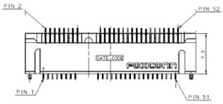

| **Pin** | **Signal** | **Signal Type** | **Signal Level** |
| --- | --- | --- | --- |
| **1** | PCIE\_WAKE# | IN |  |
| **2** | +3.3V | PWR | +3.3V |
| **3** | NC |  |  |
| **4** | GND | GND |  |
| **5** | NC |  |  |
| **6** | +1.5V | PWR | +1.5V |
| **7** | PCIE\_CLK\_REQ# | IN |  |
| **8** | NC | PWR |  |
| **9** | GND | GND |  |
| **10** | NC | I/O |  |
| **11** | PCIE\_REF\_CLK- | DIFF |  |
| **12** | NC | IN |  |
| **13** | PCIE\_REF\_CLK+ | DIFF |  |
| **14** | NC | IN |  |
| **15** | GND | GND |  |
| **16** | NC | PWR |  |
| **17** | NC |  |  |
| **18** | GND | GND |  |
| **19** | NC |  |  |
| **20** | W\_DISABLE# | OUT | +3.3V |
| **21** | GND | GND |  |
| **22** | PCIE\_RST# | OUT | +3.3V |
| **23** | PCIE\_RX- | DIFF |  |
| **24** | +3.3VSB | PWR | +3.3V |
| **25** | PCIE\_RX+ | DIFF |  |
| **26** | GND | GND |  |
| **27** | GND | GND |  |
| **28** | +1.5V | PWR | +1.5V |
| **29** | GND | GND |  |
| **30** | SMB\_CLK | I/O | +3.3V |
| **31** | PCIE\_TX- | DIFF |  |
| **32** | SMB\_DATA | I/O | +3.3V |
| **33** | PCIE\_TX+ | DIFF |  |
| **34** | GND | GND |  |
| **35** | GND | GND |  |
| **36** | USB\_D- | DIFF |  |
| **37** | GND | GND |  |
| **38** | USB\_D+ | DIFF |  |
| **39** | +3.3VSB | PWR | +3.3V |
| **40** | GND | GND |  |
| **41** | +3.3VSB | PWR | +3.3V |
| **42** | NC |  |  |
| **43** | GND | GND |  |
| **44** | NC |  |  |
| **45** | NC |  |  |
| **46** | NC |  |  |
| **47** | NC |  |  |
| **48** | +1.5V | PWR | +1.5V |
| **49** | NC |  |  |
| **50** | GND | GND |  |
| **51** | NC |  |  |
| **52** | +3.3VSB | PWR | +3.3V |

### 2.4.18 Mini Card Slot with mSATA (Full Sized) (PCIE2)

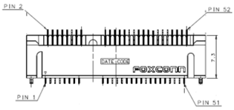

| **Pin** | **Signal** | **Signal Type** | **Signal Level** |
| --- | --- | --- | --- |
| **1** | PCIE\_WAKE# | IN |  |
| **2** | +3.3V | PWR | +3.3V |
| **3** | NC |  |  |
| **4** | GND | GND |  |
| **5** | NC |  |  |
| **6** | +1.5V | PWR | +1.5V |
| **7** | PCIE\_CLK\_REQ# | IN |  |
| **8** | NC | PWR |  |
| **9** | GND | GND |  |
| **10** | NC | I/O |  |
| **11** | PCIE\_REF\_CLK- | DIFF |  |
| **12** | NC | IN |  |
| **13** | PCIE\_REF\_CLK+ | DIFF |  |
| **14** | NC | IN |  |
| **15** | GND | GND |  |
| **16** | NC | PWR |  |
| **17** | NC |  |  |
| **18** | GND | GND |  |
| **19** | NC |  |  |
| **20** | W\_DISABLE# | OUT | +3.3V |
| **21** | GND | GND |  |
| **22** | PCIE\_RST# | OUT | +3.3V |
| **23** | PCIE\_RX- | DIFF |  |
| **24** | +3.3VSB | PWR | +3.3V |
| **25** | PCIE\_RX+ | DIFF |  |
| **26** | GND | GND |  |
| **27** | GND | GND |  |
| **28** | +1.5V | PWR | +1.5V |
| **29** | GND | GND |  |
| **30** | SMB\_CLK | I/O | +3.3V |
| **31** | PCIE\_TX- | DIFF |  |
| **32** | SMB\_DATA | I/O | +3.3V |
| **33** | PCIE\_TX+ | DIFF |  |
| **34** | GND | GND |  |
| **35** | GND | GND |  |
| **36** | USB\_D- | DIFF |  |
| **37** | GND | GND |  |
| **38** | USB\_D+ | DIFF |  |
| **39** | +3.3VSB | PWR | +3.3V |
| **40** | GND | GND |  |
| **41** | +3.3VSB | PWR | +3.3V |
| **42** | NC |  |  |
| **43** | GND | GND |  |
| **44** | NC |  |  |
| **45** | NC |  |  |
| **46** | NC |  |  |
| **47** | NC |  |  |
| **48** | +1.5V | PWR | +1.5V |
| **49** | NC |  |  |
| **50** | GND | GND |  |
| **51** | NC |  |  |
| **52** | +3.3VSB | PWR | +3.3V |

### 2.4.19 SATA PWR (PWR 1,2)

SATA_PWR 4PIN

|  |  |  |  |
| --- | --- | --- | --- |
| **Pin** | **Signal** | **Signal Type** | **Signal Level** |
| **1** | +12V | PWR | +12V |
| **2** | GND | GND |  |
| **3** | GND | GND |  |
| **4** | +5V | PWR | +5V |

### 2.4.20 SATA Port (SATA 3,4)

**SATA**

|  |  |  |  |
| --- | --- | --- | --- |
| **Pin** | **Signal** | **Signal Type** | **Signal Level** |
| **1** | GND | GND |  |
| **2** | SATA\_TX+ | DIFF |  |
| **3** | SATA\_TX- | DIFF |  |
| **4** | GND | GND |  |
| **5** | SATA\_RX- | DIFF |  |
| **6** | SATA\_RX+ | DIFF |  |
| **7** | GND | GND |  |

### 2.4.21 SIM Slot (SIM1)

| **Pin** | **Signal** | **Signal Type** | **Signal Level** |
| --- | --- | --- | --- |
| **1** | UIM\_PWR | PWR |  |
| **2** | UIM\_RST | IN |  |
| **3** | UIM\_CLK | IN |  |
| **4** | GND | GND |  |
| **5** | UIM\_VPP | PWR |  |
| **6** | UIM\_DATA | I/O |  |

## 2.5 CPU Installation

Before installing the CPU, ensure the system is powered down and disconnect the power cord from the system. Make sure you have the processor ready to install. See Chapter 1 Specifications for list of compatible CPU/processors.

**Step 1:** Remove the screws on the front and back of the BOXER-6839-CFL as shown in the figure below (six in total), and remove the top heatsink.



**Step 2:** Install the CPU into the socket and place the thermal pad on top of the processor.



**Step 3:** Place the heatsink back on and secure with the screws you removed in Step 1.

## 2.6 Expansion Card Installation

Before installing expansion cards, ensure the system is powered down and disconnect the power cord from the system. Make sure you have the expansion card ready to install. See Chapter 1 for expansion card requirements and specifications.

**Step 1:** Remove the eight (8) screws from the bottom of the BOXER-6839-CFL. Remove the bottom panel from the system. Also remove the expansion card bracket by removing the two (2) screws holding it in place.



**Step 2:** Remove the expansion bay cover and install the expansion card. Secure to the chassis with a screw.

**Step 3:** Reattach the expansion card bracket and secure with the two screws removed in Step 1. Then, replace and secure the bottom panel with the eight screws removed in Step 1. You can skip this step if you also need to install the 2.5” SATA drives.

## 2.7 2.5” SATA Drive Installation

Before installing the 2.5” SATA drive(s), ensure the system is powered down and disconnect the power cord from the system. Make sure you have the 2.5” SATA drive(s) ready to install. See Chapter 1 for 2.5” SATA drive requirements and specifications.

**Step 1:** Remove the eight (8) screws from the bottom of the BOXER-6839-CFL. Remove the bottom panel from the system.



**Step 2:** Install the 2.5” SATA drives into the SATA drive mount shown. Secure with four side screws.

**Step 3:** Attach the SATA and SATA Power cables to the board and the SATA drive.



**Step 4:** Replace the bottom panel and secure with the eight (8) screws you removed in Step 1.

## 2.8 Wallmount Assembly

**Step 1:** Line up the wallmount brackets in the mounting kit with the holes as shown. The middle hole should line up with the bottom panel screw such that you can easily remove the screw from the bottom panel without having to remove the bracket



**Step 2**: Use the four screws included with the wallmount kit to secure the wall mount brackets.

**Chapter 3**

# Chapter 3 - AMI BIOS Setup

## 3.1 System Test and Initialization

The system uses certain routines to perform testing and initialization during the boot up sequence. If an error, fatal or non-fatal, is encountered, the system will output a few short beeps or an error message. The board can usually continue the boot up sequence with non-fatal errors.

The system configuration verification routines check the current system configuration against the values stored in the CMOS memory. If they do not match, an error message will be output, and the BIOS setup program will need to be run to set the configuration information in memory.

There are three situations in which the CMOS settings will need to be set or changed:

* Starting the system for the first time
* The system hardware has been changed
* The CMOS memory has lost power and the configuration information is erased

The system’s CMOS memory uses a backup battery for data retention. The battery must be replaced when it runs down.

## 3.2 AMI BIOS Setup

The AMI BIOS ROM has a pre-installed Setup program that allows users to modify basic system configurations, which is stored in the battery-backed CMOS RAM and BIOS NVRAM so that the information is retained when the power is turned off.

To enter BIOS Setup, press <Del> or <F2> immediately while your computer is powering up.

The function for each interface can be found below.

**Main** – Date and time can be set here. Press <Tab> to switch between date elements

**Advanced** – Enable/ Disable boot option for legacy network devices

**Chipset** – For hosting bridge parameters

**Security** – The setup administrator password can be set here

**Boot** – Enable/ Disable Quiet Boot option

**Save & Exit –**Save your changes and exit the program

## 3.3 Setup Submenu: Main

***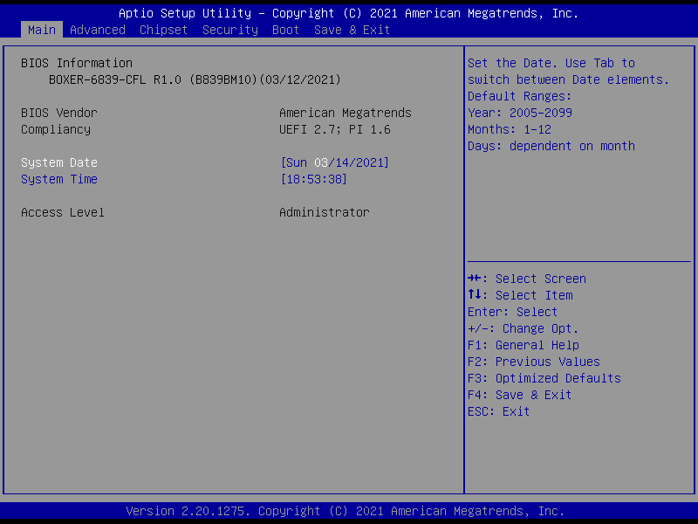***

## 3.4 Setup Submenu: Advanced

***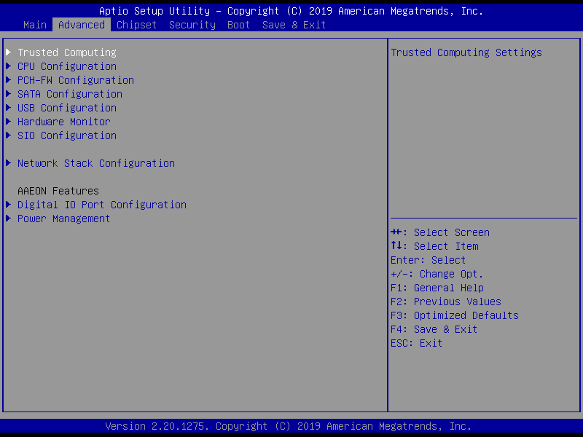***

### 3.4.1 Advanced: Trusted Computing

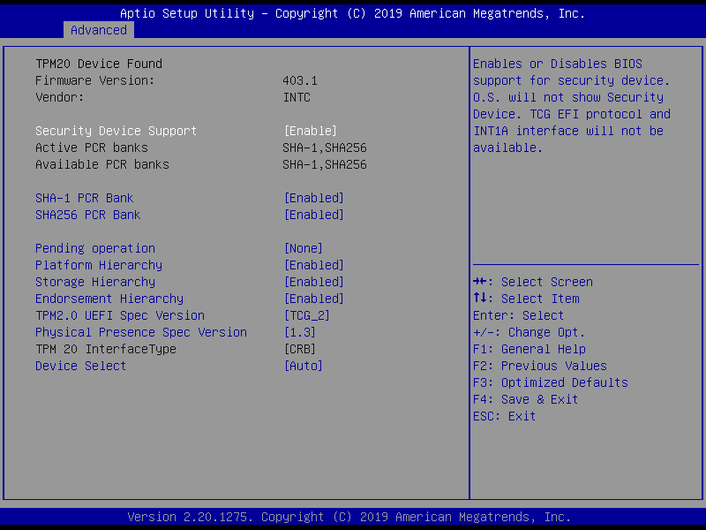

| **Options Summary** | | |
| --- | --- | --- |
| **Security Device Support** | Enable | Optimal Default, Failsafe Default |
| Disable |  |
| Enable or Disable BIOS support for security device. TCG EFI protocol and INT1A interface will not be available. | | |
| **SHA-1 PCR Bank** | Enabled | Optimal Default, Failsafe Default |
| Disabled |  |
| Enable or Disable SHA-1 PCR Bank | | |
| **SHA256 PCR Bank** | Enabled | Optimal Default, Failsafe Default |
| Disabled |  |
| Enable or Disable SHA256 PCR Bank | | |
| **Pending operation** | None | Optimal Default, Failsafe Default |
| TPM Clear |  |
| Schedule an Operation for the Security Device. NOTE: Your Computer will reboot during restart in order to change State of Security Device. | | |
|  | | |
| *Table Continues on Next Page* | | |
| **Platform Hierarchy** | Enabled | Optimal Default, Failsafe Default |
| Disabled |  |
| Enable or Disable Platform Hierarchy | | |
| **Storage Hierarchy** | Enabled | Optimal Default, Failsafe Default |
| Disabled |  |
| Enable or Disable Storage Hierarchy | | |
| **Endorsement Hierarchy** | Enabled | Optimal Default, Failsafe Default |
| Disabled |  |
| Enable or Disable Endorsement Hierarchy | | |
| **TPM2.0 UEFI Spec Version** | TCG\_2 | Optimal Default, Failsafe Default |
| TCG\_1\_2 |  |
| Select the TCG2 Spec Version Support  TCG\_1\_2: Compatible mode for Win8/Win10  TCG\_2: Support new TCG2 protocol and event format for Win10 or later | | |
| **Physical Presence Spec Version** | 1.3 | Optimal Default, Failsafe Default |
| 1.2 |  |
| Select to Tell O.S. to support PPI Spec Version 1.2 or 1.3. Note some HCK tests might not support 1.3. | | |
| **Device Select** | Auto | Optimal Default, Failsafe Default |
| TPM 1.2 |  |
| TPM 2.0 |  |
| TPM 1.2 will restrict support to TPM 1.2 devices, TPM 2.0 will restrict support to TPM 2.0 devices, Auto will support both with the default set to TPM 2.0 devices if not found, TPM 1.2 devices will be enumerated | | |

### 3.4.2 Advanced: CPU Configuration

***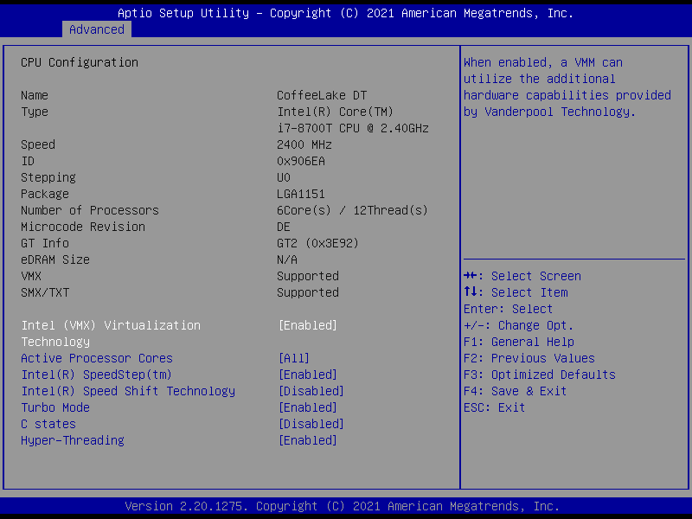***

| **Options Summary** | | |
| --- | --- | --- |
| **Intel (VMX) Virtualization Technology** | Disabled |  |
| Enabled | Optimal Default, Failsafe Default |
| When enabled, a VMM can utilize the additional hardware capabilities provided by Vanderpool Technology. | | |
| **Active Processor Cores** | 1 |  |
| 2 |  |
| 3 |  |
| All | Optimal Default, Failsafe Default |
| Number of cores to enable in each processor package. | | |
| **Intel(R) SpeedStep(tm)** | Disabled |  |
| Enabled | Optimal Default, Failsafe Default |
| Allows more than two frequency ranges to be supported. | | |
| **Intel(R) Speed Shift Technology** | Disabled | Optimal Default, Failsafe Default |
| Enabled |  |
| Enable/Disable Intel(R) Speed Shift Technology support. Enabling will expose the CPPC v2 interface to allow for hardware controlled P-states. | | |
| **Turbo Mode** | Disabled |  |
| Enabled | Optimal Default, Failsafe Default |
| Enable/Disable Processor Turbo Mode (requires Intel Speed Step or Intel Speed Shift to be available or enabled). | | |
| **C states** | Disabled | Optimal Default, Failsafe Default |
| Enabled |  |
| Enable/Disable CPU Power Management. Allows CPU to go C states when it’s not 100% utilized | | |
| **Hyper-Threading** | Disabled |  |
| Enabled | Optimal Default, Failsafe Default |
| Enabled or Disabled Hyper-Threading Technology. | | |

### 3.4.3 Advanced: PCH-FW Configuration

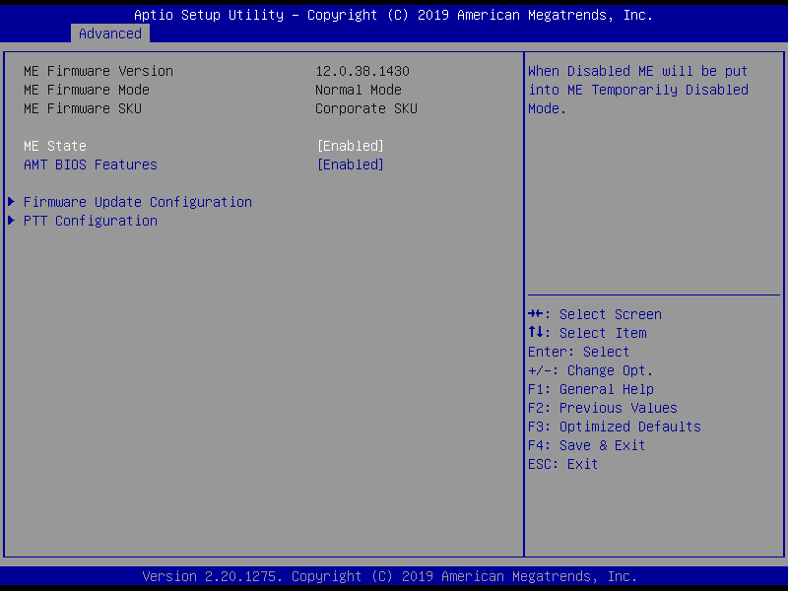

| **Options Summary** | | |
| --- | --- | --- |
| **ME State** | Enabled | Optimal Default, Failsafe Default |
| Disabled |  |
| When Disabled ME will be put into ME Temporarily Disabled Mode. | | |
| **AMT BIOS Feature** | Enabled | Optimal Default, Failsafe Default |
| Disabled |  |
| When disabled AMT BIOS Features are no longer supported and user is no longer able to access MEBx Setup.  **Note**: This option does not disable Manageability Features in FW. | | |

#### 3.4.3.1 Firmware Update Configuration

**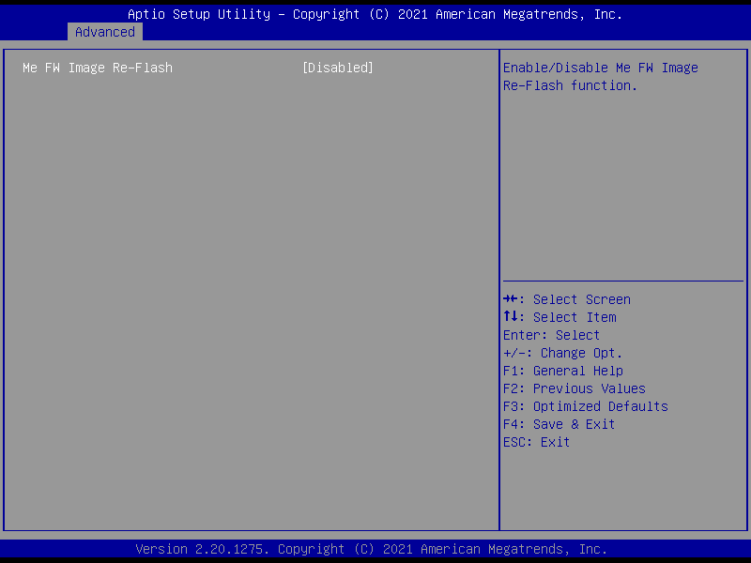**

| **Options Summary** | | |
| --- | --- | --- |
| **ME FW Image Re-Flash** | Enabled |  |
| Disabled | Optimal Default, Failsafe Default |
| Enable/Disable ME FW Image Re-Flash function. | | |

#### 3.4.3.2 PTT Configuration

**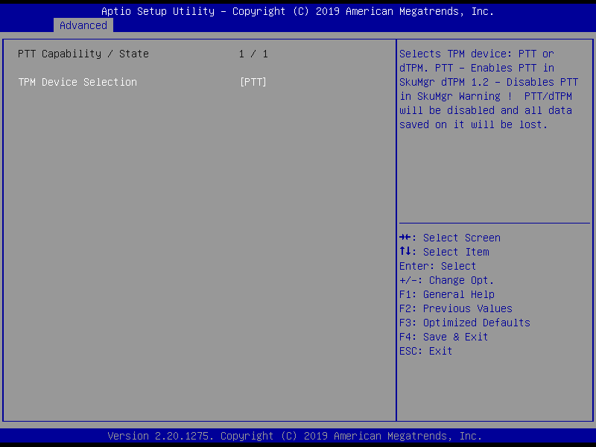**

| **Options Summary** | | |
| --- | --- | --- |
| **ME FW Image Re-Flash** | dTPM |  |
| PTT | Optimal Default, Failsafe Default |
| Selects TPM device: PTT or dTPM.  PTT – Enables PTT in SkuMgr  dTPM 1.2 – Disables PTT in SkuMgr  **Warning!** PTT/dTPM will be disabled and all saved data will be lost. | | |

### 3.4.4 Advanced: SATA Configuration

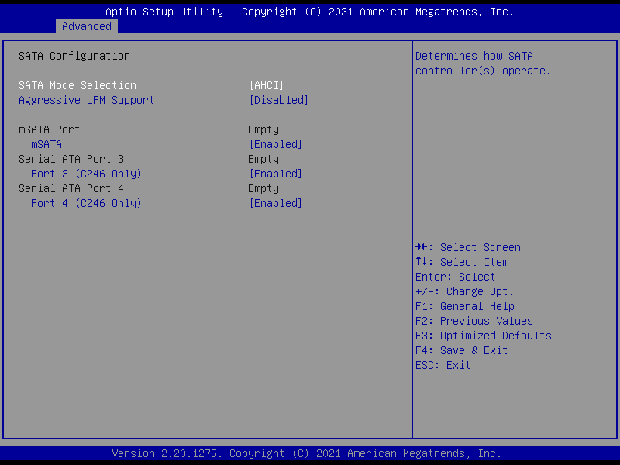

| **Options Summary** | | |
| --- | --- | --- |
| **SATA Mode Selection** | AHCI Mode | Optimal Default, Failsafe Default |
| Intel RST Premium With Intel Optane System Acceleration |  |
| Determines how SATA controller(s) operate. | | |
| **Aggressive LPM Support** | Enabled |  |
| Disabled | Optimal Default, Failsafe Default |
| Enable PCH to aggressively enter link power state. | | |
| **mSATA** | Enabled | Optimal Default, Failsafe Default |
| Disabled |  |
| Enable or Disable SATA Port. | | |
| **Port 3/4** | Enabled | Optimal Default, Failsafe Default |
| Disabled |  |
| Enable or Disable SATA Port. | | |

### 3.4.5 Advanced: USB Configuration

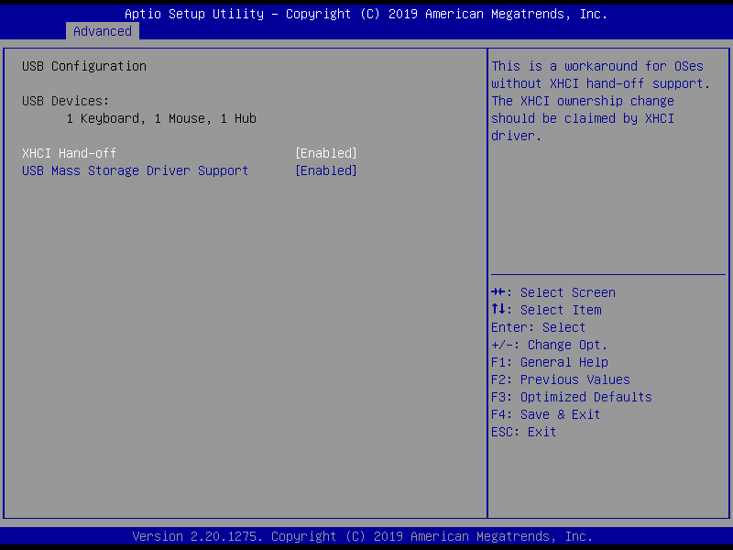

| **Options Summary** | | |
| --- | --- | --- |
| **XHCI Hand-off** | Enabled | Optimal Default, Failsafe Default |
| Disabled |  |
| This is a workaround for OSes without XHCI Hand-off support. The XHCI ownership change should be claimed by XHCI driver. | | |
| **USB Mass Storage Driver Support** | Enabled | Optimal Default, Failsafe Default |
| Disabled |  |
| Enable/Disable USB Mass Storage Driver Support. | | |

### 3.4.6 Advanced: Hardware Monitor

**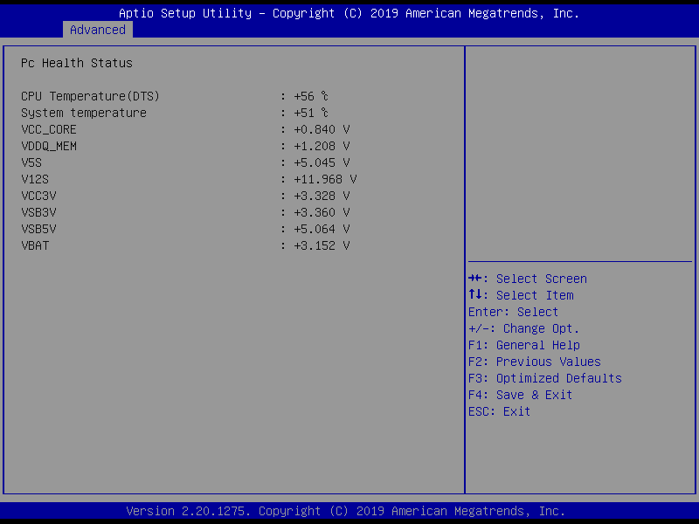**

### 3.4.7 Advanced: SIO Configuration

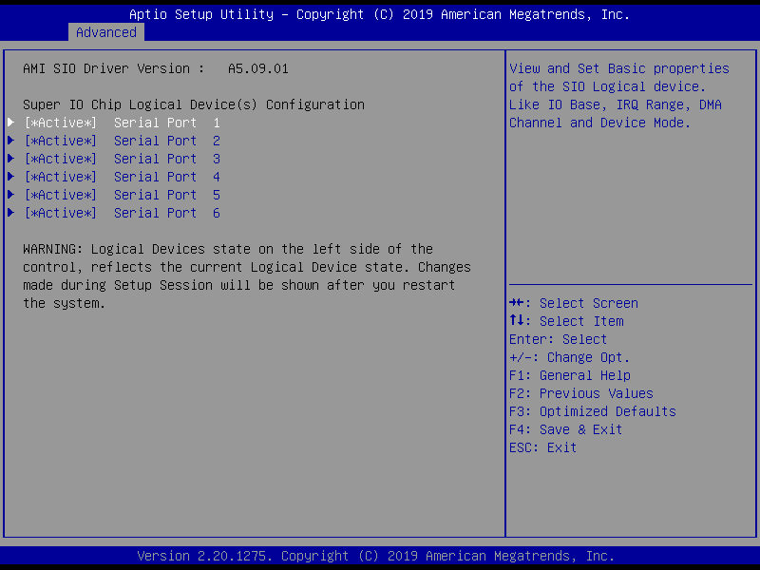

#### 3.4.7.1 Serial Port 1 Configuration

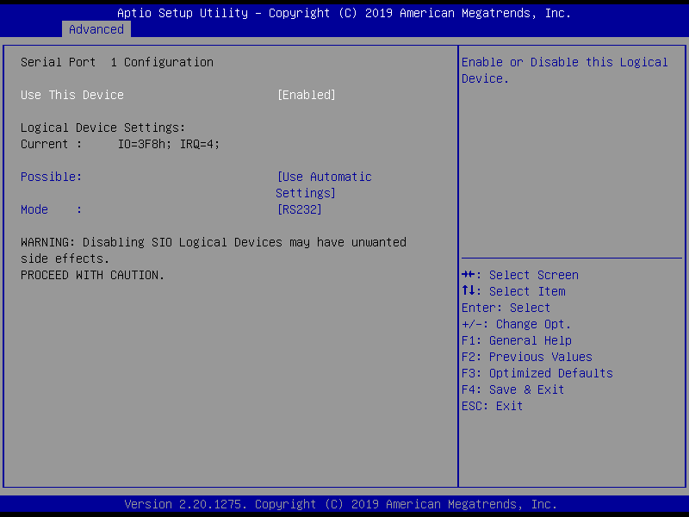

| **Options Summary** | | |
| --- | --- | --- |
| **Use This Device** | Enabled | Optimal Default, Failsafe Default |
| Disabled |  |
| Enabled or Disabled this Logical Device. | | |
| **Device resource settings** | USB Automatic Setting | Optimal Default, Failsafe Default |
| IO=3F8h; IRQ = 4; |  |
| IO=2F8h; IRQ = 3; |  |
| Allows the user to change the device resource settings. New settings will be reflected on this setup page after system restarts. | | |
| **UART selection** | RS232 | Optimal Default, Failsafe Default |
| RS422 |  |
| RS485 |  |
| UART RS232, 422, 485 selection. | | |

#### 3.4.7.2 Serial Port 2 Configuration

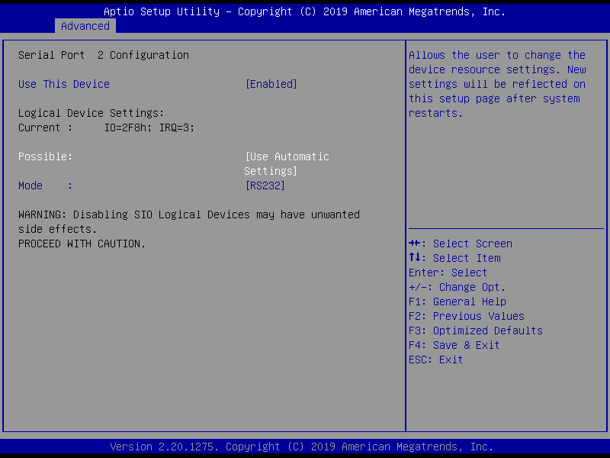

| **Options Summary** | | |
| --- | --- | --- |
| **Use This Device** | Enabled | Optimal Default, Failsafe Default |
| Disabled |  |
| Enabled or Disabled this Logical Device. | | |
| **Device resource settings** | USB Automatic Setting | Optimal Default, Failsafe Default |
| IO=2F8h; IRQ = 3; |  |
| IO=3F8h; IRQ = 4; |  |
| Allows the user to change the device resource settings. New settings will be reflected on this setup page after system restarts. | | |
| **UART selection** | RS232 | Optimal Default, Failsafe Default |
| RS422 |  |
| RS485 |  |
| UART RS232, 422, 485 selection. | | |

#### 3.4.7.3 Serial Port 3 Configuration

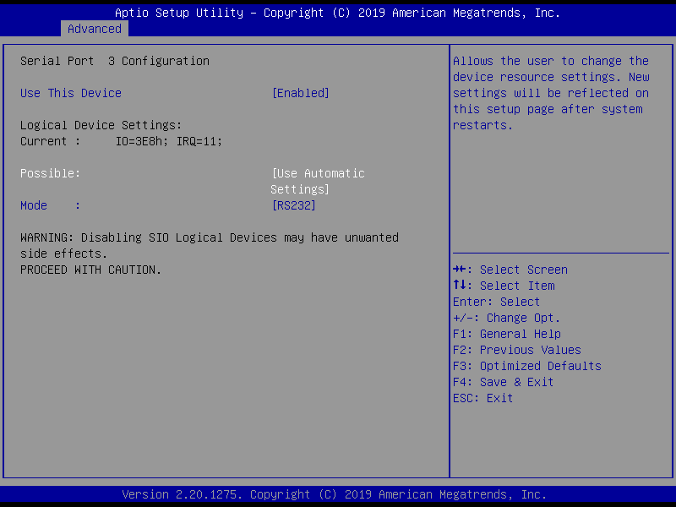

| **Options Summary** | | |
| --- | --- | --- |
| **Use This Device** | Enabled | Optimal Default, Failsafe Default |
| Disabled |  |
| Enabled or Disabled this Logical Device. | | |
| **Device resource settings** | USB Automatic Setting | Optimal Default, Failsafe Default |
| IO=3E8h; IRQ = 11; |  |
| IO=2E8h; IRQ = 11; |  |
| Allows the user to change the device resource settings. New settings will be reflected on this setup page after system restarts. | | |
| **UART selection** | RS232 | Optimal Default, Failsafe Default |
| RS422 |  |
| RS485 |  |
| UART RS232, 422, 485 selection. | | |

#### 3.4.7.4 Serial Port 4 Configuration

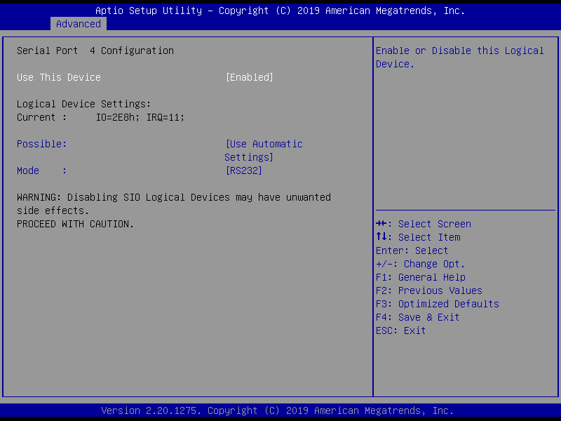

| **Options Summary** | | |
| --- | --- | --- |
| **Use This Device** | Enabled | Optimal Default, Failsafe Default |
| Disabled |  |
| Enabled or Disabled this Logical Device. | | |
| **Device resource settings** | USB Automatic Setting | Optimal Default, Failsafe Default |
| IO=2E8h; IRQ = 11; |  |
| IO=3E8h; IRQ = 11; |  |
| Allows the user to change the device resource settings. New settings will be reflected on this setup page after system restarts. | | |
| **UART selection** | RS232 | Optimal Default, Failsafe Default |
| RS422 |  |
| RS485 |  |
| UART RS232, 422, 485 selection. | | |

#### 3.4.7.5 Serial Port 5 Configuration

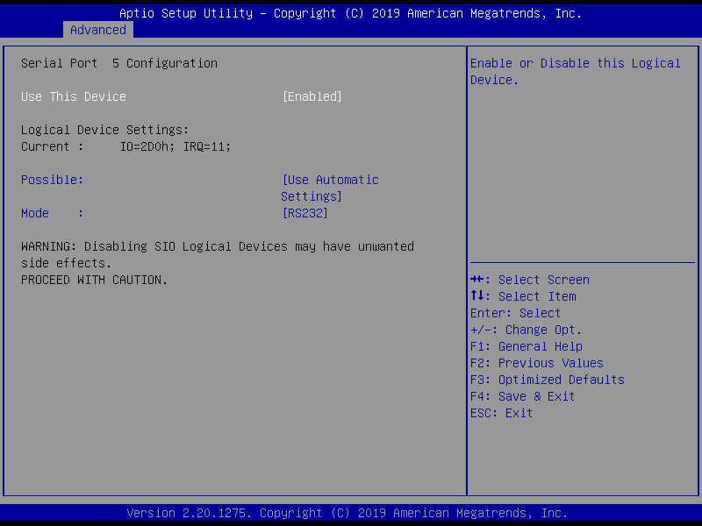

| **Options Summary** | | |
| --- | --- | --- |
| **Use This Device** | Enabled | Optimal Default, Failsafe Default |
| Disabled |  |
| Enabled or Disabled this Logical Device. | | |
| **Device resource settings** | USB Automatic Setting | Optimal Default, Failsafe Default |
| IO=2D0h; IRQ = 11; |  |
| IO=2C0h; IRQ = 11; |  |
| Allows the user to change the device resource settings. New settings will be reflected on this setup page after system restarts. | | |
| **UART selection** | RS232 | Optimal Default, Failsafe Default |
| RS422 |  |
| RS485 |  |
| UART RS232, 422, 485 selection. | | |

#### 3.4.7.6 Serial Port 6 Configuration

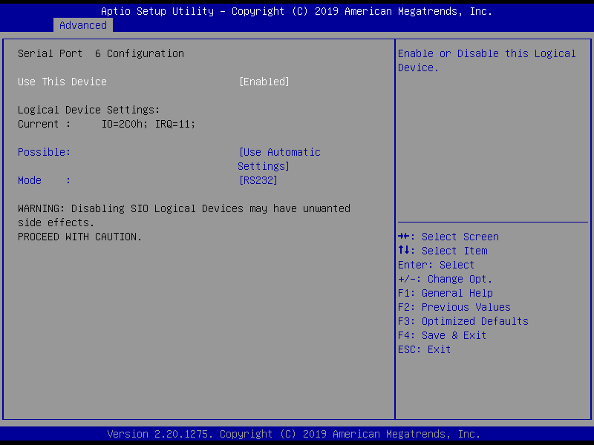

| **Options Summary** | | |
| --- | --- | --- |
| **Use This Device** | Enabled | Optimal Default, Failsafe Default |
| Disabled |  |
| Enabled or Disabled this Logical Device. | | |
| **Device resource settings** | USB Automatic Setting | Optimal Default, Failsafe Default |
| IO=2C0h; IRQ = 11; |  |
| IO=2D0h; IRQ = 11; |  |
| Allows the user to change the device resource settings. New settings will be reflected on this setup page after system restarts. | | |
| **UART selection** | RS232 | Optimal Default, Failsafe Default |
| RS422 |  |
| RS485 |  |
| UART RS232, 422, 485 selection. | | |

### 3.4.8 Advanced: Network Stack Configuration

**Network Stack Disabled:**

**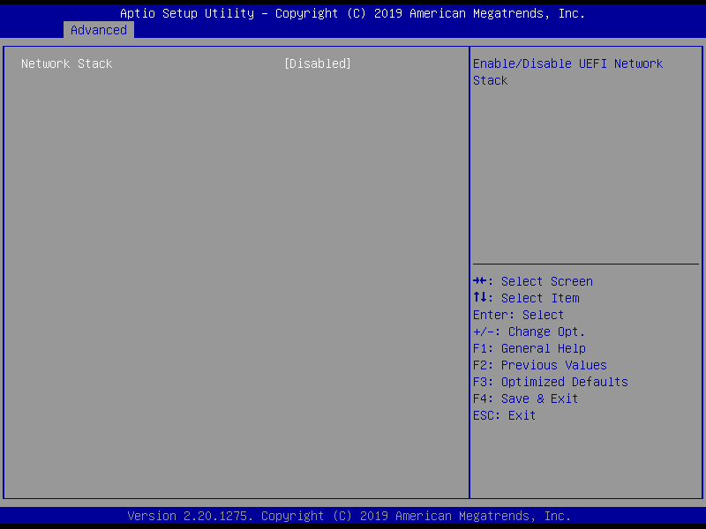**

| **Options Summary** | | |
| --- | --- | --- |
| **Network Stack** | Disabled |  |
| Enabled | Optimal Default, Failsafe Default |
| Enable/Disable UEFI Network Stack | | |

**Network Stack Enabled:**

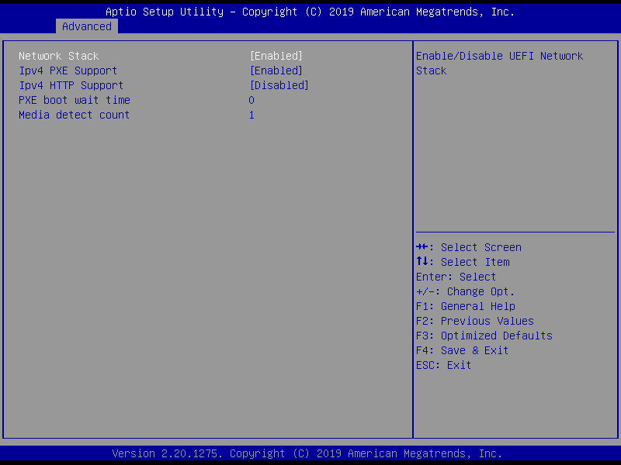

| **Options Summary** | | |
| --- | --- | --- |
| **Network Stack** | Disabled |  |
| Enabled | Optimal Default, Failsafe Default |
| Enable/Disable UEFI Network Stack | | |
| **Ipv4 PXE Support** | Disabled |  |
| Enabled | Optimal Default, Failsafe Default |
| Enable/Disable IPv4 PXE boot support. If disabled, IPv4 PXE boot support will not be available. | | |
| **Ipv4 HTTP Support** | Disabled | Optimal Default, Failsafe Default |
| Enabled |  |
| Enable/Disable IPv4 HTTP boot support. If disabled, IPv4 HTTP boot support will not be available. | | |
| **PXE boot wait time** | 0 | Optimal Default, Failsafe Default |
| Wait time in seconds to press ESC key to abort the PXE boot. Use either +/- or numeric keys to set the value. | | |
|  | | |
| *Table Continues on Next Page…* | | |
| **Media detect count** | 1 | Optimal Default, Failsafe Default |
| Number of times the presence of media will be checked. Use either +/- or numeric keys to set the value. | | |

### 3.4.9 Advanced: Digital IO Port Configuration

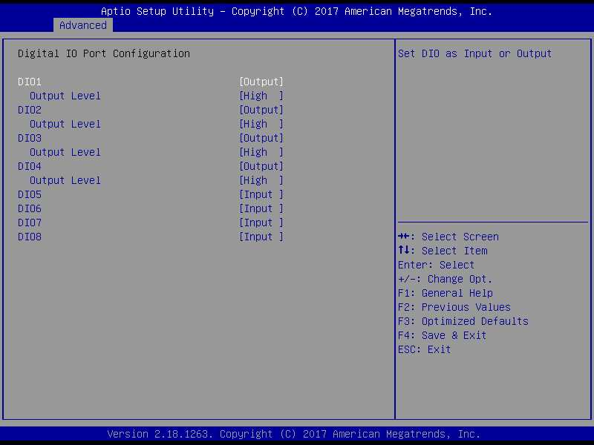

| **Options Summary** | | |
| --- | --- | --- |
| **DIO Type** | Output | Optimal Default, Failsafe Default |
| Input |  |
| Set DIO as Input or Output | | |
| **DIO Data** | Low |  |
| High | Optimal Default, Failsafe Default |
| Set is output level when DIO pin is output | | |

### 3.4.10 Advanced: Power Management

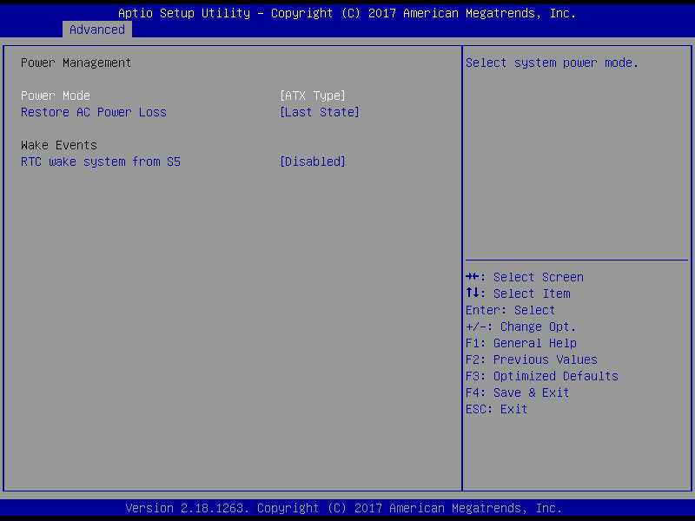

| **Options Summary** | | |
| --- | --- | --- |
| **Power Mode** | ATX Type | Optimal Default, Failsafe Default |
| AT Type |  |
| Select power supply mode. | | |
| **AC Power Loss** | Last State | Optimal Default, Failsafe Default |
| Power On |  |
| Power Off |  |
| Select power state when power is re-applied after a power failure. | | |
| **RTC wake system from S5** | Disabled | Optimal Default, Failsafe Default |
| Enabled |  |
| Fixed Time: System will make on the hr::min::sec specified.  Dynamic Time: System will wake on the current time + Increase minute(S) | | |
| **RTC wake system from S5** | Enabled |  |
| **Wake up day** | 0 |  |
| Select 0 for daily system wake up, 1-31 for which day of the month that you would like system to wake up | | |
| **Wake up hour** | 0 |  |
| Select 0-23; For example enter 3 for 3am and 15 for 3pm | | |
| **Wake up minute** | 0 |  |
| 0 – 59 | | |
| **Wake up second** | 0 |  |
| 0 - 59 | | |

## 3.5 Setup Submenu: Chipset

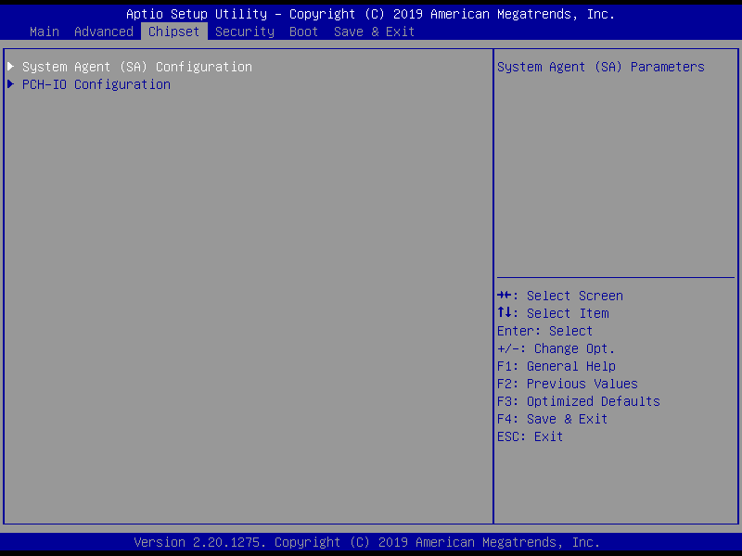

### 3.5.1 Chipset: System Agent (SA) Configuration

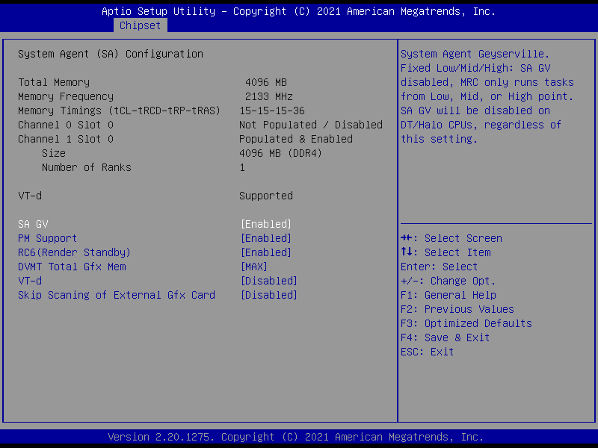

| **Options Summary** | | |
| --- | --- | --- |
| **SA GV** | Enabled | Optimal Default, Failsafe Default |
| Disabled |  |
| Fixed Low |  |
| Fixed High |  |
| System Agent Geyserville.  Fixed Low/Mid/High: SA GV disabled, MRC only runs tasks from Low, Mid, or High point. SA GV will be disabled on DT/Halo CPUs, regardless of this setting. | | |
| **PM Support** | Enabled | Optimal Default, Failsafe Default |
| Disabled |  |
| Enable/Disable PM Support. | | |
| **RC6(Render Standby)** | Enabled | Optimal Default, Failsafe Default |
| Disabled |  |
| Check to enable render standby support. | | |
|  | | |
| *Table Continues on Next Page…* | | |
|  | | |
| **DVMT Total Gfx Mem** | 128M |  |
| 256M |  |
| MAX | Optimal Default, Failsafe Default |
| Select DVMT5.0 Total Graphic Memory sized used by the Internal Graphics Device. | | |
| **VT-d** | Enabled |  |
| Disabled | Optimal Default, Failsafe Default |
| VT-d capability. | | |
| **Skip Scaning of External Gfx Card** | Enabled |  |
| Disabled | Optimal Default, Failsafe Default |
| If Enabled, it will not scan for External Gfx Card on PEG and PCH PCIE Ports | | |

### 3.5.2 Chipset: PCH-IO Configuration

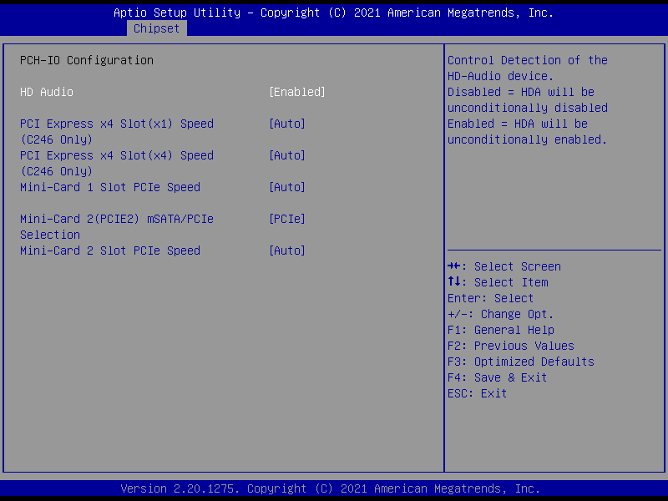

| **Options Summary** | | |
| --- | --- | --- |
| **HD Audio** | Enabled | Optimal Default, Failsafe Default |
| Disabled |  |
| Control the Detection of the Audio device.  Disabled = HDA will be unconditionally disabled.  Enabled = HDA will be unconditionally enabled. | | |
| **PCI Express x4 Slot(x1) Speed (C246 Only)** | Auto | Optimal Default, Failsafe Default |
| Gen 1 |  |
| Gen 2 |  |
| Gen 3 |  |
| Configure PCIe Speed. | | |
| **PCI Express x4 Slot(x4) Speed (C246 Only)** | Auto | Optimal Default, Failsafe Default |
| Gen 1 |  |
| Gen 2 |  |
| Gen 3 |  |
| Configure PCIe Speed. | | |
|  |  |  |
| **Mini-Card 1 Slot PCIe Speed** | Auto | Optimal Default, Failsafe Default |
| Gen 1 |  |
| Gen 2 |  |
| Configure PCIe Speed. | | |
| **Mini-Card 2(PCIE2) mSATA/PCIe Selection** | mSATA | Optimal Default, Failsafe Default |
| PCIe |  |
| Select mSATA or PCIe function for Mini-Card 2(PCIE2). | | |
| **Mini-Card 2 Slot PCIe Speed** | Auto | Optimal Default, Failsafe Default |
| Gen1 |  |
| Gen2 |  |
| Configure PCIe Speed  (Note: This setup will show when setup “Mini-Card 2(PCIE2) mSATA/PCIe Selection”  Is PCIe) | | |

## 3.6 Setup Submenu: Security

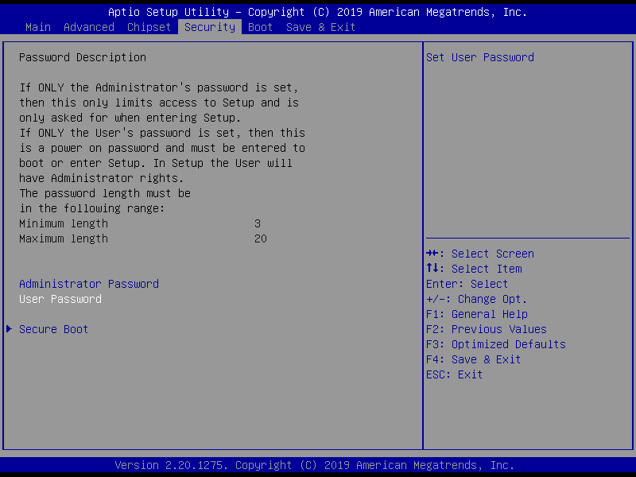

**Change User/Administrator Password**

You can set an Administrator Password or User Password. An Administrator Password must be set before you can set a User Password. The password will be required during boot up, or when the user enters the Setup utility. A User Password does not provide access to many of the features in the Setup utility.

Select the password you wish to set, and press Enter. In the dialog box, enter your password (must be between 3 and 20 letters or numbers). Press Enter and retype your password to confirm. Press Enter again to set the password.

**Removing the Password**

Select the password you want to remove and enter the current password. At the next dialog box press Enter to disable password protection.

### 3.6.1 Security: Secure Boot

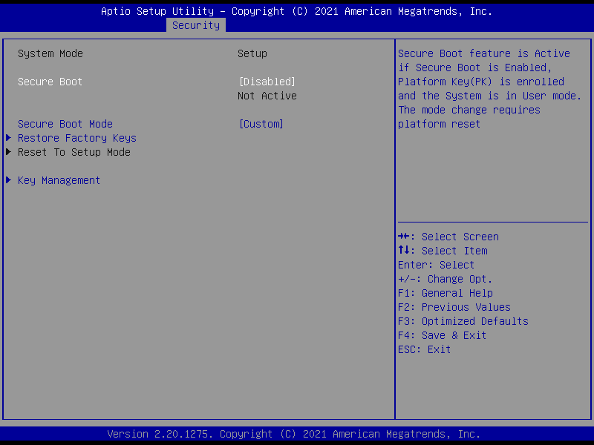

| **Options Summary** | | |
| --- | --- | --- |
| **Secure Boot** | Disable | Optimal Default, Failsafe Default |
| Enable |  |
| Secure Boot feature is Active if Secure Boot is Enabled, Platform Key (PK) is enrolled and the System mode is in User mode. The mode change requires platform reset. | | |
| **Secure Boot Mode** | Standard |  |
| Custom | Optimal Default, Failsafe Default |
| Secure Boot Mode options: Standard or Custom.  In Custom mode, Secure Boot Policy variables can be configured by a physically present user without full authentication. | | |
| **Restore Factory Keys** | Yes |  |
| No |  |
| Force System to User Mode. Install factory default Secure Boot key databases | | |
| Reset To Setup Mode | No | Deleting all variables will reset the System to Setup Mode |
|  | Yes |
| Delete all Secure Boot key databases from NVRAM. | | |
|  | | |
| *Table Continues on Next Page…* | | |
| **Key Management** |  |  |
| Enables expert users to modify Secure Boot Policy variables without full authentication | | |

#### 3.6.1.1 Key Management

**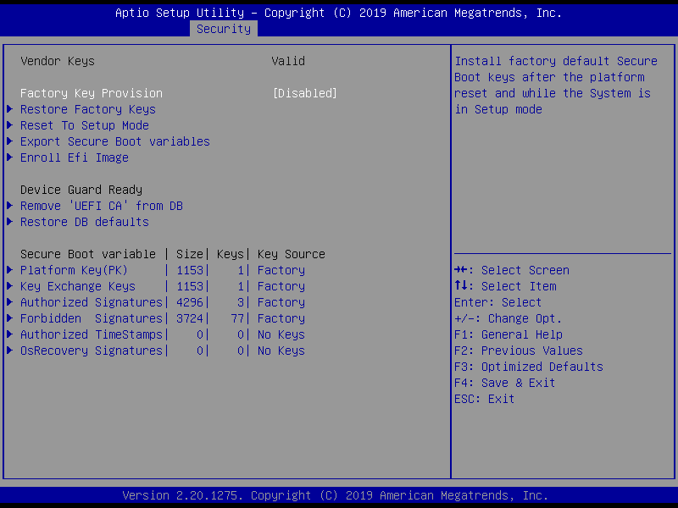**

| **Options Summary** | | |
| --- | --- | --- |
| **Factory key Provision** | Disabled | Optimal Default, Failsafe Default |
| Enabled |  |
| Install factory default Secure Boot keys after the platform reset and while the System is in Setup mode. | | |
| **Restore Factory Keys** | No | Press ‘Yes’ to install factory default keys |
| Yes |
| Force System to User Mode. Install Factory default Secure Boot key databases. | | |
| **Reset To Setup Mode** | No |  |
| Yes | Deleting all variables will reset the System to Setup Mode. |
| Delete all Secure Boot key databases from NVRAM. | | |
| **Export Secure Boot variables** |  | |
| Copy NVRAM content of Secure Boot variables to files in a root folder on a file system device. | | |
|  | | |
| **Enroll Efi Image** |  | |
| Allow the image to run in Secure Boot mode.  Enroll SHA256 Hash Certificate of a PE Image into Authorized Signature Database (db). | | |

| **Device Guard Ready** | | |
| --- | --- | --- |
| **Remove ‘UEFI CA’ from SB** | No | Press ‘Yes’ to remove ‘UEFI CA’ from SB |
| Yes |
| Device Guard ready system must not list ’Microsoft UEFI CA’ Certificate in Authorized Signature database(db). | | |
| **Restore DB defaults** | No |  |
| Yes | Press ‘Yes’ to Restore DB defaults |
| Restore DB variable to factory defaults. | | |

| **Secure Boot variable |Size | Keys#| key Source** | | |
| --- | --- | --- |
| Platform key(PK) | 1153 | 1 | No Key | Details | Enroll Factory Defaults or load certificates from a file:  1.Public key Certificate:  a)EFI\_SIGNATURE\_LIST  b)EFI\_CERT\_X509 (DER)  c)EFI\_CERT\_RSA2048 (bin)  d)EFI\_CERT\_SHAXXX  2.Authenticated UEFI Variable  3.EFI PE/COFF Image(SHA256)  Key Source:  Factory, External, Mixed |
| Export |
| Update |
| Delete |
| Key Exchange keys | 1153 | 1 | No Key | Details | Enroll Factory Defaults or load certificates from a file:  1.Public key Certificate:  a)EFI\_SIGNATURE\_LIST  b)EFI\_CERT\_X509 (DER)  c)EFI\_CERT\_RSA2048 (bin)  d)EFI\_CERT\_SHAXXX  2.Authenticated UEFI Variable  3.EFI PE/COFF Image(SHA256)  Key Source:  Factory, External, Mixed |
| Export |
| Update |
| Append |
| Delete |
|  |  |  |
| *Table Continues on Next Page…* | | |
| Authorized Signatures| 4296 | 3 | No Key | Details | Enroll Factory Defaults or load certificates from a file:  1.Public key Certificate:  a)EFI\_SIGNATURE\_LIST  b)EFI\_CERT\_X509 (DER)  c)EFI\_CERT\_RSA2048 (bin)  d)EFI\_CERT\_SHAXXX  2.Authenticated UEFI Variable  3.EFI PE/COFF Image(SHA256)  Key Source:  Factory, External, Mixed |
| Export |
| Update |
| Append |
| Delete |
| Forbidden Signatures | 3274 | 77 | No Key | Details | Enroll Factory Defaults or load certificates from a file:  1.Public key Certificate:  a)EFI\_SIGNATURE\_LIST  b)EFI\_CERT\_X509 (DER)  c)EFI\_CERT\_RSA2048 (bin)  d)EFI\_CERT\_SHAXXX  2.Authenticated UEFI Variable  3.EFI PE/COFF Image(SHA256)  Key Source:  Factory, External, Mixed |
| Export |
| Update |
| Append |
| Delete |
| Authorized TimeStamps| 0 | 0 | No Key | Update | Enroll Factory Defaults or load certificates from a file:  1.Public key Certificate:  a)EFI\_SIGNATURE\_LIST  b)EFI\_CERT\_X509 (DER)  c)EFI\_CERT\_RSA2048 (bin)  d)EFI\_CERT\_SHAXXX  2.Authenticated UEFI Variable  3.EFI PE/COFF Image(SHA256)  Key Source:  Factory, External, Mixed |
| Append |
|  |  |  |
|  |  |  |
| *Table Continues on Next Page* | | |
|  |  |  |
|  |  |  |
|  |  |  |
|  |  |  |
|  |  |  |
| OsRecovery Signatures| 0 | 0 | No Key | Update | Enroll Factory Defaults or load certificates from a file:  1.Public key Certificate:  a)EFI\_SIGNATURE\_LIST  b)EFI\_CERT\_X509 (DER)  c)EFI\_CERT\_RSA2048 (bin)  d)EFI\_CERT\_SHAXXX  2.Authenticated UEFI Variable  3.EFI PE/COFF Image(SHA256)  Key Source:  Factory, External, Mixed |
| Append |

## 3.7 Setup Submenu: Boot

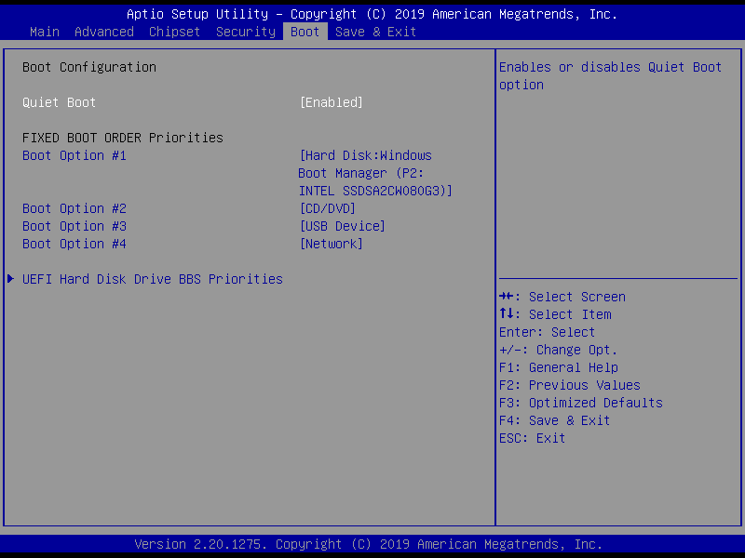

| **Options Summary** | | |
| --- | --- | --- |
| **Quiet Boot** | Disabled |  |
| Enabled | Optimal Default, Failsafe Default |
| Enables or disables Quiet Boot option. | | |

## 3.8 Setup Submenu: Save & Exit

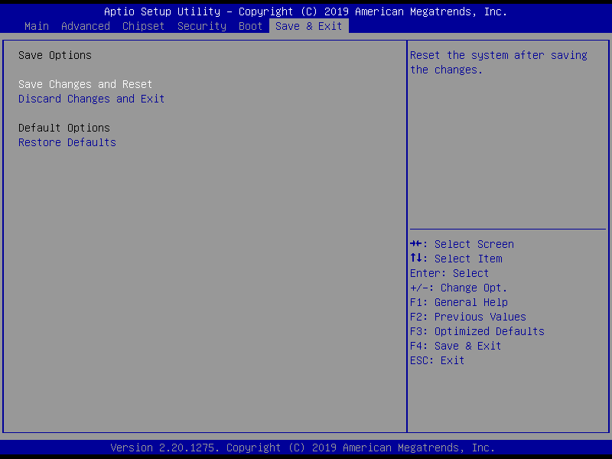

**Chapter 4**

# Chapter 4 – Drivers Installation

## 4.1 Drivers Download and Installation

Drivers for the BOXER-6839-CFL can be downloaded from the product page on the AAEON website by following this link:

[https://www.aaeon.com/en/p/fanless-embedded-box-pc-socket-type-boxer-6839-CFL](https://www.aaeon.com/en/p/fanless-embedded-box-pc-socket-type-boxer-6641)

Download the driver(s) you need and follow the steps below to install them.

**Install Chipset Drivers**

1. Open the **Step1 - Chipset** folder and select your OS
2. Run the **SetupChipset.exe** file in the folder
3. Follow the instructions
4. Drivers will be installed automatically

**Install Graphics Drivers**

1. Open the **Step2 - Graphic**folder and select your OS
2. Run the **igxpin.exe.**file in the folder
3. Follow the instructions
4. Drivers will be installed automatically

**Install ME Drivers**

1. Open the **Step3 - ME**folder and select your OS
2. Run the **SetupME.exe**file in the folder
3. Follow the instructions
4. Drivers will be installed automatically

**Install LAN Drivers**

1. Open the **Step4 - LAN** folder and select your OS
2. Run the **PROWinx64\_23.5.2.exe** file in the folder
3. Follow the instructions
4. Drivers will be installed automatically

**Install Audio Drivers**

1. Open the **Step5 – Audio**folder and select your OS
2. Run the **0008-64bit\_Win7\_Win8\_Win81\_Win10\_R281.exe** file in the folder
3. Follow the instructions
4. Drivers will be installed automatically

**Install Intel RST Drivers**

1. Open the **Step6 – Intel RST**folder and select your OS
2. Run the **SetupRST.exe** file in the folder
3. Follow the instructions
4. Drivers will be installed automatically

**Install Serial Port Drivers (Optional)**

1. Open the **Step7 – Serial Port Driver (Optional)** folder
2. Run the **FintekSerial.exe** file in the folder
3. Follow the instructions
4. Drivers will be installed automatically

**Appendix A**

# Appendix A - Watchdog Timer Programming

## A.1 Watchdog Timer Initial Program

|  |  |  |
| --- | --- | --- |
| **Table 1: Super IO relative register table** | | |
|  | **Default Value** | **Note** |
| **Index** | **0x2E**(Note1) | SIO MB PnP Mode Index Register  0x2E or 0x4E |
| **Data** | **0x2F**(Note2) | SIO MB PnP Mode Data Register  0x2F or 0x4F |

|  |  |  |  |  |  |
| --- | --- | --- | --- | --- | --- |
| **Table 2: Watchdog relative register table** | | | | | |
|  | **LDN** | **Register** | **BitNum** | **Value** | **Note** |
| **Timer Counter** | **0x07**(Note3) | **0xF6**(Note4) |  | (Note24) | Time of watchdog timer  (0~255)  This register is byte access |
| **Counting Unit** | **0x07**(Note5) | **0xF5**(Note6) | **3**(Note7) | **0**(Note8) | Select time unit.  0: second  1: minute |
| **Watchdog Enable** | **0x07**(Note9) | **0xF5**(Note10) | **5**(Note11) | **1**(Note12) | 0: Disable  1: Enable |
| **Timeout Status** | **0x07**(Note13) | **0xF5**(Note14) | **6**(Note15) | **1** | 1: Clear timeout status |
| **Output Mode** | **0x07**(Note16) | **0xF5**(Note17) | **4**(Note18) | **1**(Note19) | Select WDTRST# output mode  0: level  1: pulse |
| **WDTRST output** | **0x07**(Note20) | **0xFA**(Note21) | **0**(Note22) | **1**(Note23) | Enable/Disable  time out output via WDTRST#  0: Disable  1: Enable |

\*\*\*\*\*\*\*\*\*\*\*\*\*\*\*\*\*\*\*\*\*\*\*\*\*\*\*\*\*\*\*\*\*\*\*\*\*\*\*\*\*\*\*\*\*\*\*\*\*\*\*\*\*\*\*\*\*\*\*\*\*\*\*\*\*\*\*\*\*\*\*\*\*\*\*\*\*\*\*\*\*\*\*\*

// SuperIO relative definition (Please reference to Table 1)

**#define byte** SIOIndex //This parameter is represented from **Note1**

**#define byte** SIOData //This parameter is represented from **Note2**

**#define** **void** IOWriteByte(**byte** IOPort, **byte** Value);

**#define byte** IOReadByte(**byte** IOPort);

// Watch Dog relative definition (Please reference to Table 2)

**#define byte** TimerLDN //This parameter is represented from **Note3**

**#define byte** TimerReg //This parameter is represented from **Note4**

**#define byte** TimerVal // This parameter is represented from **Note24**

**#define byte** UnitLDN //This parameter is represented from **Note5**

**#define byte** UnitReg //This parameter is represented from **Note6**

**#define byte** UnitBit //This parameter is represented from **Note7**

**#define byte** UnitVal //This parameter is represented from **Note8**

**#define byte** EnableLDN //This parameter is represented from **Note9**

**#define byte** EnableReg //This parameter is represented from **Note10**

**#define byte** EnableBit //This parameter is represented from **Note11**

**#define byte** EnableVal //This parameter is represented from **Note12**

**#define byte** StatusLDN // This parameter is represented from **Note13**

**#define byte** StatusReg // This parameter is represented from **Note14**

**#define byte** StatusBit // This parameter is represented from **Note15**

**#define byte** ModeLDN // This parameter is represented from **Note16**

**#define byte** ModeReg // This parameter is represented from **Note17**

**#define byte** ModeBit // This parameter is represented from **Note18**

**#define byte** ModeVal // This parameter is represented from **Note19**

**#define byte** WDTRstLDN // This parameter is represented from **Note20**

**#define byte** WDTRstReg // This parameter is represented from **Note21**

**#define byte** WDTRstBit // This parameter is represented from **Note22**

**#define byte** WDTRstVal // This parameter is represented from **Note23**

\*\*\*\*\*\*\*\*\*\*\*\*\*\*\*\*\*\*\*\*\*\*\*\*\*\*\*\*\*\*\*\*\*\*\*\*\*\*\*\*\*\*\*\*\*\*\*\*\*\*\*\*\*\*\*\*\*\*\*\*\*\*\*\*\*\*\*\*\*\*\*\*\*\*\*\*\*\*\*\*\*\*\*\*

\*\*\*\*\*\*\*\*\*\*\*\*\*\*\*\*\*\*\*\*\*\*\*\*\*\*\*\*\*\*\*\*\*\*\*\*\*\*\*\*\*\*\*\*\*\*\*\*\*\*\*\*\*\*\*\*\*\*\*\*\*\*\*\*\*\*\*\*\*\*\*\*\*\*\*\*\*\*\*\*\*\*\*\*

VOID **Main**(){

// Procedure : AaeonWDTConfig

// (byte)Timer : Time of WDT timer.(0x00~0xFF)

// (boolean)Unit : Select time unit(0: second, 1: minute).

AaeonWDTConfig();

// Procedure : AaeonWDTEnable

// This procudure will enable the WDT counting.

AaeonWDTEnable();

}

\*\*\*\*\*\*\*\*\*\*\*\*\*\*\*\*\*\*\*\*\*\*\*\*\*\*\*\*\*\*\*\*\*\*\*\*\*\*\*\*\*\*\*\*\*\*\*\*\*\*\*\*\*\*\*\*\*\*\*\*\*\*\*\*\*\*\*\*\*\*\*\*\*\*\*\*\*\*\*\*\*\*\*\*

\*\*\*\*\*\*\*\*\*\*\*\*\*\*\*\*\*\*\*\*\*\*\*\*\*\*\*\*\*\*\*\*\*\*\*\*\*\*\*\*\*\*\*\*\*\*\*\*\*\*\*\*\*\*\*\*\*\*\*\*\*\*\*\*\*\*\*\*\*\*\*\*\*\*\*\*\*\*\*\*\*\*\*\*

// Procedure : AaeonWDTEnable

VOID **AaeonWDTEnable ()**{

WDTEnableDisable(**EnableLDN**, **EnableReg**, **EnableBit**, **1**);

}

// Procedure : AaeonWDTConfig

VOID **AaeonWDTConfig ()**{

// Disable WDT counting

WDTEnableDisable(**EnableLDN**, **EnableReg**, **EnableBit**, **0**);

// Clear Watchdog Timeout Status

WDTClearTimeoutStatus();

// WDT relative parameter setting

WDTParameterSetting();

}

VOID **WDTEnableDisable(byte LDN, byte Register, byte BitNum, byte Value)**{

SIOBitSet(LDN, Register, BitNum, Value);

}

VOID **WDTParameterSetting()**{

// Watchdog Timer counter setting

SIOByteSet(**TimerLDN**, **TimerReg**, **TimerVal**);

// WDT counting unit setting

SIOBitSet(**UnitLDN**, **UnitReg**, **UnitBit**, **UnitVal**);

// WDT output mode setting, level / pulse

SIOBitSet(**ModeLDN**, **ModeReg**, **ModeBit**, **ModeVal**);

// Watchdog timeout output via WDTRST#

SIOBitSet(**WDTRstLDN**, **WDTRstReg**, **WDTRstBit**, **WDTRstVal**);

}

VOID **WDTClearTimeoutStatus()**{

SIOBitSet(**StatusLDN**, **StatusReg**, **StatusBit**, **1**);

}

\*\*\*\*\*\*\*\*\*\*\*\*\*\*\*\*\*\*\*\*\*\*\*\*\*\*\*\*\*\*\*\*\*\*\*\*\*\*\*\*\*\*\*\*\*\*\*\*\*\*\*\*\*\*\*\*\*\*\*\*\*\*\*\*\*\*\*\*\*\*\*\*\*\*\*\*\*\*\*\*\*\*\*\*

\*\*\*\*\*\*\*\*\*\*\*\*\*\*\*\*\*\*\*\*\*\*\*\*\*\*\*\*\*\*\*\*\*\*\*\*\*\*\*\*\*\*\*\*\*\*\*\*\*\*\*\*\*\*\*\*\*\*\*\*\*\*\*\*\*\*\*\*\*\*\*\*\*\*\*\*\*\*\*\*\*\*\*\*

VOID **SIOEnterMBPnPMode()**{

IOWriteByte(SIOIndex, 0x87);

IOWriteByte(SIOIndex, 0x87);

}

VOID **SIOExitMBPnPMode()**{

IOWriteByte(SIOIndex, 0xAA);

}

VOID **SIOSelectLDN(byte LDN)**{

IOWriteByte(SIOIndex, 0x07); // SIO LDN Register Offset = 0x07

IOWriteByte(SIOData, LDN);

}

VOID **SIOBitSet(byte LDN, byte Register, byte BitNum, byte Value)**{

Byte TmpValue;

SIOEnterMBPnPMode();

SIOSelectLDN(byte LDN);

IOWriteByte(SIOIndex, Register);

TmpValue = IOReadByte(SIOData);

TmpValue &= ~(1 << BitNum);

TmpValue |= (Value << BitNum);

IOWriteByte(SIOData, TmpValue);

SIOExitMBPnPMode();

}

VOID **SIOByteSet(byte LDN, byte Register, byte Value)**{

SIOEnterMBPnPMode();

SIOSelectLDN(LDN);

IOWriteByte(SIOIndex, Register);

IOWriteByte(SIOData, Value);

SIOExitMBPnPMode();

}

\*\*\*\*\*\*\*\*\*\*\*\*\*\*\*\*\*\*\*\*\*\*\*\*\*\*\*\*\*\*\*\*\*\*\*\*\*\*\*\*\*\*\*\*\*\*\*\*\*\*\*\*\*\*\*\*\*\*\*\*\*\*\*\*\*\*\*\*\*\*\*\*\*\*\*\*\*\*\*\*\*\*\*\*

**Appendix B**

# Appendix B - I/O Information

## B.1 I/O Address Map

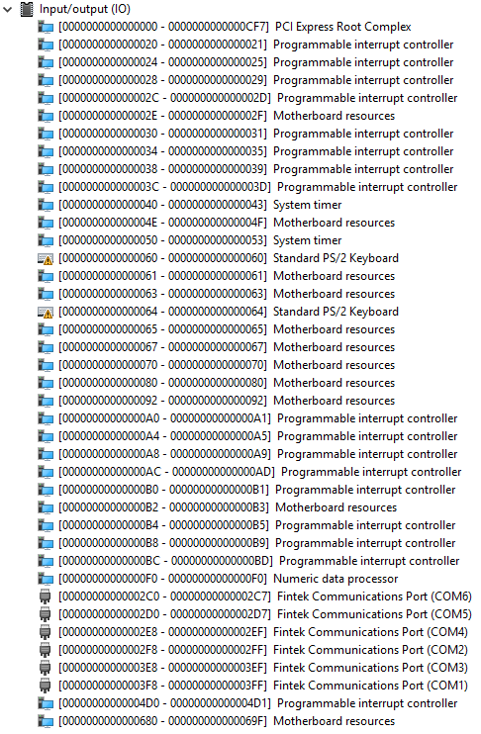

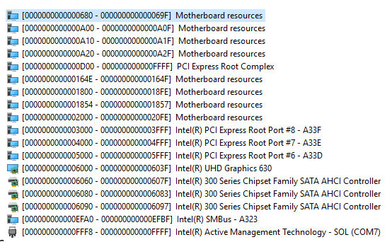

## B.2 IRQ Mapping Chart

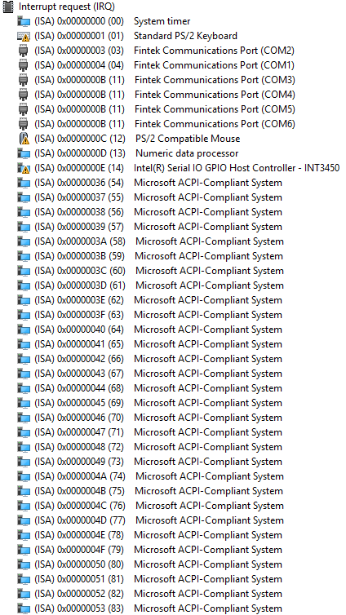

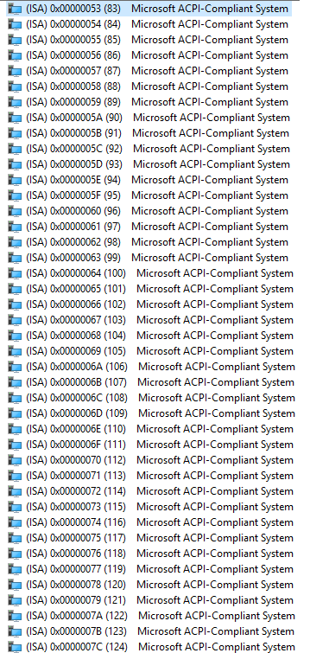

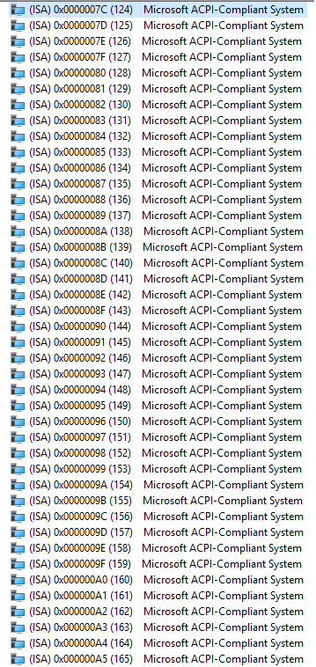

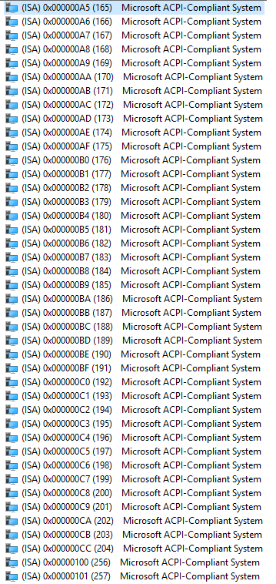

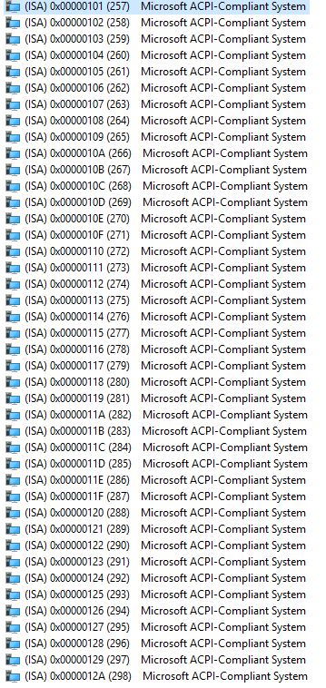

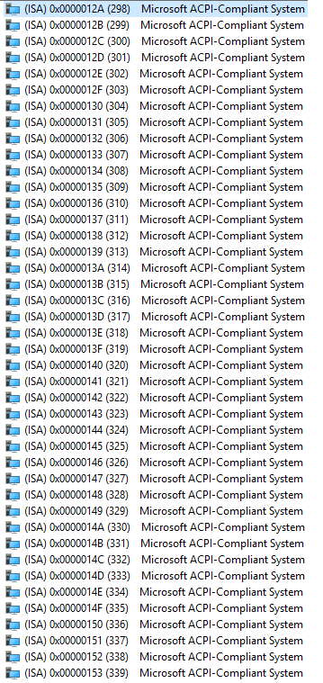

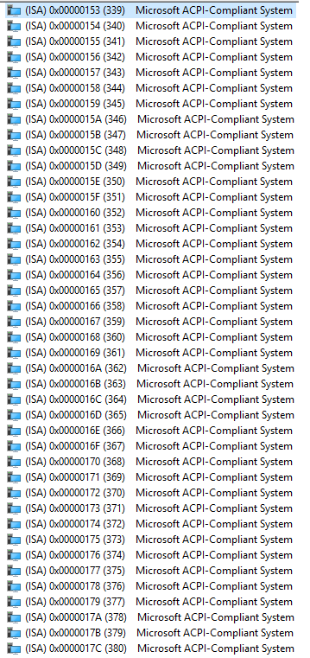

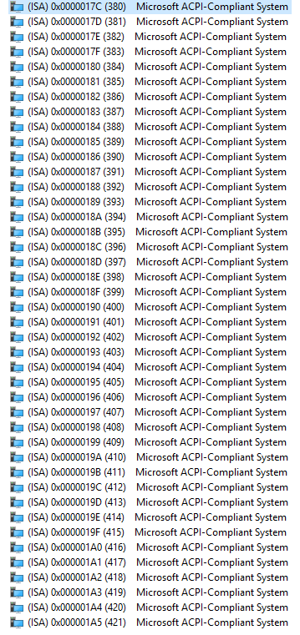

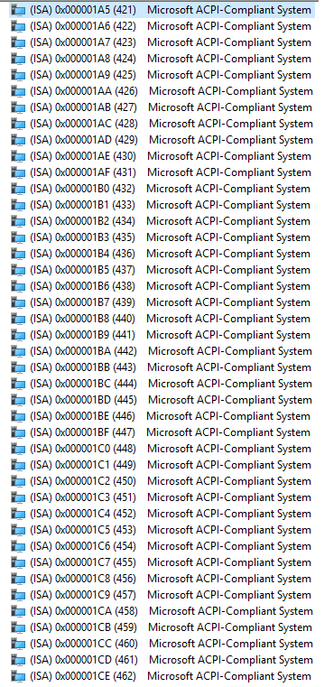

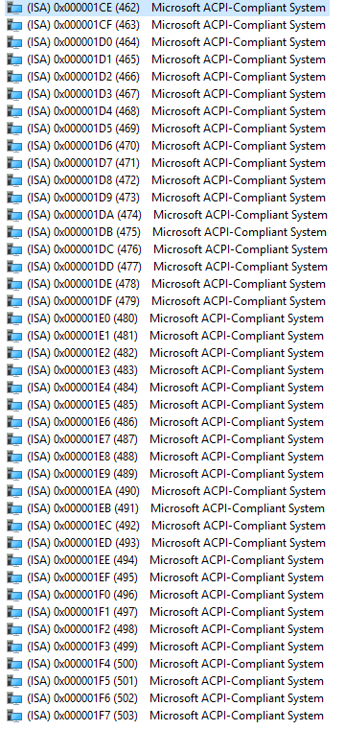

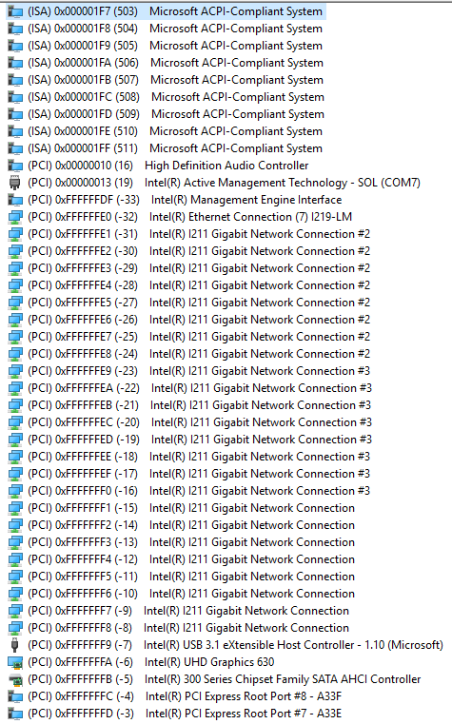

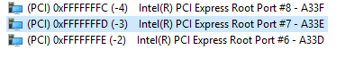

## B.3 Memory Address Map

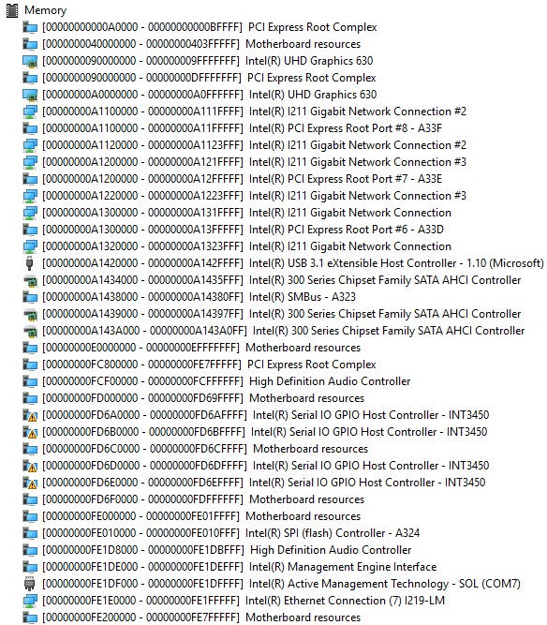

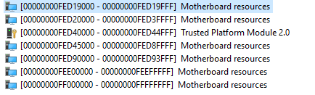

**Appendix C**

# Appendix C - Digital I/O Ports

## C.1 Electrical Specifications for Digital I/O Ports

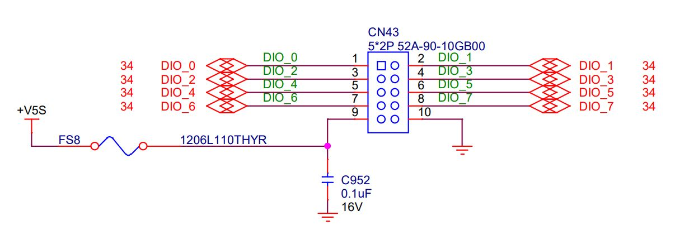

|  |  |
| --- | --- |
| GPIO70 | DIO\_0 |
| GPIO71 | DIO\_1 |
| GPIO72 | DIO\_2 |
| GPIO73 | DIO\_3 |
| GPIO74 | DIO\_4 |
| GPIO75 | DIO\_5 |
| GPIO76 | DIO\_6 |
| GPIO77 | DIO\_7 |

## C.2 DIO Programming

BOXER-6839-CFL utilizes FINTEK F81966 chipset as its Digital I/O controller. The following sections detail the procedures to complete its configuration. The AAEON initial DIO program is also attached to help with developing a customized program for your application.

There are three steps to complete the configuration setup:

**Step 1** Enter MB PnP Mode.

**Step 2** Modify the data in the configuration registers.

**Step 3** Exit MB PnP Mode. Undesired results may occur if MB PnP Mode is not exited properly.

## C.3 Digital I/O Register

|  |  |  |
| --- | --- | --- |
| **Table 1: SuperIO relative register table** | | |
|  | **Default Value** | **Note** |
| **Index** | **0x2E**(Note1) | SIO MB PnP Mode Index Register  0x2E or 0x4E |
| **Data** | **0x2F**(Note2) | SIO MB PnP Mode Data Register  0x2F or 0x4F |

|  |  |  |  |  |  |
| --- | --- | --- | --- | --- | --- |
| **Table 2: Digital Input relative register table** | | | | | |
|  | **LDN** | **Register** | **BitNum** | **Value** | **Note** |
| **DIO-1 Pin Status** | **0x06**(Note3) | **0x82**(Note4) | **0**(Note5) |  | GPIO70 |
| **DIO-2 Pin Status** | **0x06**(Note6) | **0x82**(Note7) | **1**(Note8) |  | GPIO71 |
| **DIO-3 Pin Status** | **0x06**(Note9) | **0x82**(Note10) | **2**(Note11) |  | GPIO72 |
| **DIO-4 Pin Status** | **0x06**(Note12) | **0x82**(Note13) | **3**(Note14) |  | GPIO73 |
| **DIO-5 Pin Status** | **0x06**(Note15) | **0x82**(Note16) | **4**(Note17) |  | GPIO74 |
| **DIO-6 Pin Status** | **0x06**(Note18) | **0x82**(Note19) | **5**(Note20) |  | GPIO75 |
| **DIO-7 Pin Status** | **0x06**(Note21) | **0x82**(Note22) | **6**(Note23) |  | GPIO76 |
| **DIO-8 Pin Status** | **0x06**(Note24) | **0x82**(Note25) | **7**(Note26) |  | GPIO77 |

|  |  |  |  |  |  |
| --- | --- | --- | --- | --- | --- |
| **Table 3: Digital Output relative register table** | | | | | |
|  | **LDN** | **Register** | **BitNum** | **Value** | **Note** |
| **DIO-1 Output Data** | **0x06**(Note27) | **0x81**(Note28) | **0**(Note29) | (Note30) | GPIO70 |
| **DIO-2 Output Data** | **0x06**(Note31) | **081**(Note32) | **1**(Note33) | (Note34) | GPIO71 |
| **DIO-3 Output Data** | **0x06**(Note35) | **0x81**(Note36) | **2**(Note37) | (Note38) | GPIO72 |
| **DIO-4 Output Data** | **0x06**(Note39) | **0x81**(Note40) | **3**(Note41) | (Note42) | GPIO73 |
| **DIO-5 Output Data** | **0x06**(Note43) | **0x81**(Note44) | **4**(Note45) | (Note46) | GPIO74 |
| **DIO-6 Output Data** | **0x06**(Note47) | **0x81**(Note48) | **5**(Note49) | (Note50) | GPIO75 |
| **DIO-7 Output Data** | **0x06**(Note51) | **0x81**(Note52) | **6**(Note53) | (Note54) | GPIO76 |
| **DIO-8 Output Data** | **0x06**(Note55) | **0x81**(Note56) | **7**(Note57) | (Note58) | GPIO77 |

## C.4 Digital I/O Sample Program

\*\*\*\*\*\*\*\*\*\*\*\*\*\*\*\*\*\*\*\*\*\*\*\*\*\*\*\*\*\*\*\*\*\*\*\*\*\*\*\*\*\*\*\*\*\*\*\*\*\*\*\*\*\*\*\*\*\*\*\*\*\*\*\*\*\*\*\*\*\*\*\*\*\*\*\*\*\*\*\*\*\*\*\*

// SuperIO relative definition (Please reference to Table 1)

**#define byte** SIOIndex //This parameter is represented from **Note1**

**#define byte** SIOData //This parameter is represented from **Note2**

**#define** **void** IOWriteByte(**byte** IOPort, **byte** Value);

**#define byte** IOReadByte(**byte** IOPort);

// Digital Input Status relative definition (Please reference to Table 2)

**#define byte** DInput1LDN // This parameter is represented from **Note3**

**#define byte** DInput1Reg // This parameter is represented from **Note4**

**#define byte** DInput1Bit // This parameter is represented from **Note5**

**#define byte** DInput2LDN // This parameter is represented from **Note6**

**#define byte** DInput2Reg // This parameter is represented from **Note7**

**#define byte** DInput2Bit // This parameter is represented from **Note8**

**#define byte** DInput3LDN // This parameter is represented from **Note9**

**#define byte** DInput3Reg // This parameter is represented from **Note10**

**#define byte** DInput3Bit // This parameter is represented from **Note11**

**#define byte** DInput4LDN // This parameter is represented from **Note12**

**#define byte** DInput4Reg // This parameter is represented from **Note13**

**#define byte** DInput4Bit // This parameter is represented from **Note14**

**#define byte** DInput5LDN // This parameter is represented from **Note15**

**#define byte** DInput5Reg // This parameter is represented from **Note16**

**#define byte** DInput5Bit // This parameter is represented from **Note17**

**#define byte** DInput6LDN // This parameter is represented from **Note18**

**#define byte** DInput6Reg // This parameter is represented from **Note19**

**#define byte** DInput6Bit // This parameter is represented from **Note20**

**#define byte** DInput7LDN // This parameter is represented from **Note21**

**#define byte** DInput7Reg // This parameter is represented from **Note22**

**#define byte** DInput7Bit // This parameter is represented from **Note23**

**#define byte** DInput8LDN // This parameter is represented from **Note24**

**#define byte** DInput8Reg // This parameter is represented from **Note25**

**#define byte** DInput8Bit // This parameter is represented from **Note26**

\*\*\*\*\*\*\*\*\*\*\*\*\*\*\*\*\*\*\*\*\*\*\*\*\*\*\*\*\*\*\*\*\*\*\*\*\*\*\*\*\*\*\*\*\*\*\*\*\*\*\*\*\*\*\*\*\*\*\*\*\*\*\*\*\*\*\*\*\*\*\*\*\*\*\*\*\*\*\*\*\*\*\*\*

\*\*\*\*\*\*\*\*\*\*\*\*\*\*\*\*\*\*\*\*\*\*\*\*\*\*\*\*\*\*\*\*\*\*\*\*\*\*\*\*\*\*\*\*\*\*\*\*\*\*\*\*\*\*\*\*\*\*\*\*\*\*\*\*\*\*\*\*\*\*\*\*\*\*\*\*\*\*\*\*\*\*\*\*

// Digital Output control relative definition (Please reference to Table 3)

**#define byte** DOutput1LDN // This parameter is represented from **Note27**

**#define byte** DOutput1Reg // This parameter is represented from **Note28**

**#define byte** DOutput1Bit // This parameter is represented from **Note29**

**#define byte** DOutput1Val // This parameter is represented from **Note30**

**#define byte** DOutput2LDN // This parameter is represented from **Note31**

**#define byte** DOutput2Reg // This parameter is represented from **Note32**

**#define byte** DOutput2Bit // This parameter is represented from **Note33**

**#define byte** DOutput2Val // This parameter is represented from **Note34**

**#define byte** DOutput3LDN // This parameter is represented from **Note35**

**#define byte** DOutput3Reg // This parameter is represented from **Note36**

**#define byte** DOutput3Bit // This parameter is represented from **Note37**

**#define byte** DOutput3Val // This parameter is represented from **Note38**

**#define byte** DOutput4LDN // This parameter is represented from **Note39**

**#define byte** DOutput4Reg // This parameter is represented from **Note40**

**#define byte** DOutput4Bit // This parameter is represented from **Note41**

**#define byte** DOutput4Val // This parameter is represented from **Note42**

**#define byte** DOutput5LDN // This parameter is represented from **Note43**

**#define byte** DOutput5Reg // This parameter is represented from **Note44**

**#define byte** DOutput5Bit // This parameter is represented from **Note45**

**#define byte** DOutput5Val // This parameter is represented from **Note46**

**#define byte** DOutput6LDN // This parameter is represented from **Note47**

**#define byte** DOutput6Reg // This parameter is represented from **Note48**

**#define byte** DOutput6Bit // This parameter is represented from **Note49**

**#define byte** DOutput6Val // This parameter is represented from **Note50**

**#define byte** DOutput7LDN // This parameter is represented from **Note51**

**#define byte** DOutput7Reg // This parameter is represented from **Note52**

**#define byte** DOutput7Bit // This parameter is represented from **Note53**

**#define byte** DOutput7Val // This parameter is represented from **Note54**

**#define byte** DOutput8LDN // This parameter is represented from **Note55**

**#define byte** DOutput8Reg // This parameter is represented from **Note56**

**#define byte** DOutput8Bit // This parameter is represented from **Note57**

**#define byte** DOutput8Val // This parameter is represented from **Note58**

\*\*\*\*\*\*\*\*\*\*\*\*\*\*\*\*\*\*\*\*\*\*\*\*\*\*\*\*\*\*\*\*\*\*\*\*\*\*\*\*\*\*\*\*\*\*\*\*\*\*\*\*\*\*\*\*\*\*\*\*\*\*\*\*\*\*\*\*\*\*\*\*\*\*\*\*\*\*\*\*\*\*\*\*

\*\*\*\*\*\*\*\*\*\*\*\*\*\*\*\*\*\*\*\*\*\*\*\*\*\*\*\*\*\*\*\*\*\*\*\*\*\*\*\*\*\*\*\*\*\*\*\*\*\*\*\*\*\*\*\*\*\*\*\*\*\*\*\*\*\*\*\*\*\*\*\*\*\*\*\*\*\*\*\*\*\*\*\*

VOID **Main**(){

Boolean PinStatus ;

// Procedure : AaeonReadPinStatus

// Input :

// Example, Read Digital I/O Pin 3 status

// Output :

// InputStatus :

// 0: Digital I/O Pin level is low

// 1: Digital I/O Pin level is High

PinStatus = AaeonReadPinStatus(**DInput3LDN**, **DInput3Reg**, **DInput3Bit**);

// Procedure : AaeonSetOutputLevel

// Input :

// Example, Set Digital I/O Pin 6 level

AaeonSetOutputLevel(**DOutput6LDN**, **DOutput6Reg**, **DOutput6Bit**, **DOutput6Val**);

}

\*\*\*\*\*\*\*\*\*\*\*\*\*\*\*\*\*\*\*\*\*\*\*\*\*\*\*\*\*\*\*\*\*\*\*\*\*\*\*\*\*\*\*\*\*\*\*\*\*\*\*\*\*\*\*\*\*\*\*\*\*\*\*\*\*\*\*\*\*\*\*\*\*\*\*\*\*\*\*\*\*\*\*\*

\*\*\*\*\*\*\*\*\*\*\*\*\*\*\*\*\*\*\*\*\*\*\*\*\*\*\*\*\*\*\*\*\*\*\*\*\*\*\*\*\*\*\*\*\*\*\*\*\*\*\*\*\*\*\*\*\*\*\*\*\*\*\*\*\*\*\*\*\*\*\*\*\*\*\*\*\*\*\*\*\*\*\*\*

Boolean **AaeonReadPinStatus(byte LDN, byte Register, byte BitNum)**{

Boolean PinStatus ;

PinStatus = SIOBitRead(LDN, Register, BitNum);

Return PinStatus ;

}

VOID **AaeonSetOutputLevel(byte LDN, byte Register, byte BitNum, byte Value)**{

ConfigToOutputMode(LDN, Register, BitNum);

SIOBitSet(LDN, Register, BitNum, Value);

}

\*\*\*\*\*\*\*\*\*\*\*\*\*\*\*\*\*\*\*\*\*\*\*\*\*\*\*\*\*\*\*\*\*\*\*\*\*\*\*\*\*\*\*\*\*\*\*\*\*\*\*\*\*\*\*\*\*\*\*\*\*\*\*\*\*\*\*\*\*\*\*\*\*\*\*\*\*\*\*\*\*\*\*\*

\*\*\*\*\*\*\*\*\*\*\*\*\*\*\*\*\*\*\*\*\*\*\*\*\*\*\*\*\*\*\*\*\*\*\*\*\*\*\*\*\*\*\*\*\*\*\*\*\*\*\*\*\*\*\*\*\*\*\*\*\*\*\*\*\*\*\*\*\*\*\*\*\*\*\*\*\*\*\*\*\*\*\*\*

VOID **SIOEnterMBPnPMode()**{

IOWriteByte(SIOIndex, 0x87);

IOWriteByte(SIOIndex, 0x87);

}

VOID **SIOExitMBPnPMode()**{

IOWriteByte(SIOIndex, 0xAA);

}

VOID **SIOSelectLDN(byte LDN)**{

IOWriteByte(SIOIndex, 0x07); // SIO LDN Register Offset = 0x07

IOWriteByte(SIOData, LDN);

}

VOID **SIOBitSet(byte LDN, byte Register, byte BitNum, byte Value)**{

Byte TmpValue;

SIOEnterMBPnPMode();

SIOSelectLDN(byte LDN);

IOWriteByte(SIOIndex, Register);

TmpValue = IOReadByte(SIOData);

TmpValue &= ~(1 << BitNum);

TmpValue |= (Value << BitNum);

IOWriteByte(SIOData, TmpValue);

SIOExitMBPnPMode();

}

VOID **SIOByteSet(byte LDN, byte Register, byte Value)**{

SIOEnterMBPnPMode();

SIOSelectLDN(LDN);

IOWriteByte(SIOIndex, Register);

IOWriteByte(SIOData, Value);

SIOExitMBPnPMode();

}

\*\*\*\*\*\*\*\*\*\*\*\*\*\*\*\*\*\*\*\*\*\*\*\*\*\*\*\*\*\*\*\*\*\*\*\*\*\*\*\*\*\*\*\*\*\*\*\*\*\*\*\*\*\*\*\*\*\*\*\*\*\*\*\*\*\*\*\*\*\*\*\*\*\*\*\*\*\*\*\*\*\*\*\*

\*\*\*\*\*\*\*\*\*\*\*\*\*\*\*\*\*\*\*\*\*\*\*\*\*\*\*\*\*\*\*\*\*\*\*\*\*\*\*\*\*\*\*\*\*\*\*\*\*\*\*\*\*\*\*\*\*\*\*\*\*\*\*\*\*\*\*\*\*\*\*\*\*\*\*\*\*\*\*\*\*\*\*\*

Boolean **SIOBitRead(byte LDN, byte Register, byte BitNum)**{

Byte TmpValue;

SIOEnterMBPnPMode();

SIOSelectLDN(LDN);

IOWriteByte(SIOIndex, Register);

TmpValue = IOReadByte(SIOData);

TmpValue &= (1 << BitNum);

SIOExitMBPnPMode();

If(TmpValue == 0)

Return 0;

Return 1;

}

VOID **ConfigToOutputMode(byte LDN, byte Register, byte BitNum)**{

Byte TmpValue, OutputEnableReg;

OutputEnableReg = Register-1;

SIOEnterMBPnPMode();

SIOSelectLDN(LDN);

IOWriteByte(SIOIndex, OutputEnableReg);

TmpValue = IOReadByte(SIOData);

TmpValue |= (1 << BitNum);

IOWriteByte(SIOData, OutputEnableReg);

SIOExitMBPnPMode();

}

\*\*\*\*\*\*\*\*\*\*\*\*\*\*\*\*\*\*\*\*\*\*\*\*\*\*\*\*\*\*\*\*\*\*\*\*\*\*\*\*\*\*\*\*\*\*\*\*\*\*\*\*\*\*\*\*\*\*\*\*\*\*\*\*\*\*\*\*\*\*\*\*\*\*\*\*\*\*\*\*\*\*\*\*

**Appendix D**

# Appendix D – Glue Removal Procedure

## D.1 Removing Glue from Your System

To protect components from damage and ensure proper operation out of the box, glue may have been applied to some cables or connectors to keep them in place during shipping. This glue must be removed before attempting to swap components or perform maintenance. This section details the steps needed to remove the glue.

Before performing any kind of system maintenance, ensure the system is shut down (not in sleep or hibernate mode) and the power cable has been removed. Follow steps in Chapter 2 to access the components inside.

You will need the following items for this step:

- Cotton or cotton swab

- Anti-static tweezers

- An alcohol solution that is at least 99.5% alcohol (ethanol solution or denatured alcohol). AAEON recommends using an eye dropper or a bottle with a nozzle as in the picture below:

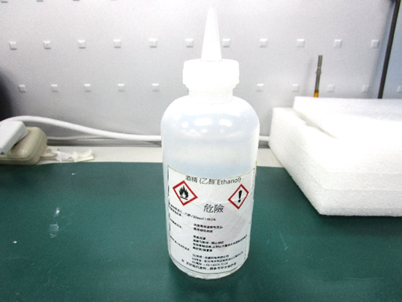

**Step 1:** Using an eyedropper or bottle as shown above, apply a few drops of alcohol to the glue.

**Step 2:** Allow the alcohol to soak for 10 seconds, then use a cotton swab or cotton with anti-static tweezers to evenly rub the alcohol over the glue.

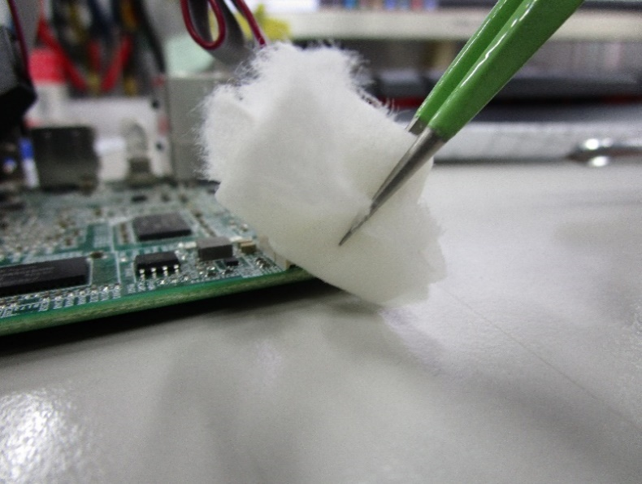

**Step 3:** Let soak for 10 more seconds, then use anti-static tweezers to remove the glue.

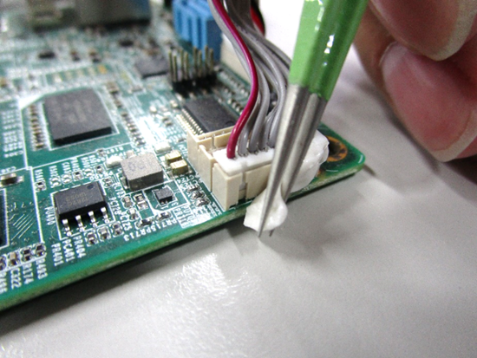

If you encounter any issues or need support, please contact your AAEON representative or visit our [Support Page](https://www.aaeon.com/en/support/) at AAEON.com